Table of contents

# If I Only Had A Brain: Memory Retention After Decapitation and Regeneration in Planaria

Francis Forde

School of Psychology, Victoria University of Wellington

# Author Note

The authors have no conflicts of interest to disclose.

# Abstract

XX

*Keywords*: Memory, Learning, Planaria, Reinstatement, Cocaine, Behaviour

# If I Only Had A Brain: Memory Retention After Decapitation and Regeneration in Planaria

# 1. Introduction

* Brief introduction to area
* Knowledge gap
* How I addressed this
* What I found
* What this might mean

# 2. Background

A brain in isolation is just a clump of extravagant cells. A brain earns its keep by liaising with the body and the external world. It is among these brain-environment interactions that an organism can set and achieve goals and, ultimately, carve a pathway to survival. But brains operate in the dark. Their only insight into the on-goings of the world is through delicately placed sensory organs such as the eyes, nose and ears.

The sensory technology that each organism possess’, what philosophers call its sensorium, differs across species. Some build a picture of the world by capturing light using light sensitive proteins. Others live where no light can penetrate and so must form their worldview using other sensory modalities like echolocation. Notwithstanding these differences, neuroscientists and biologists seek to understand the suite of abilities each organism possesses, the neuronal and molecular mechanisms which underpin these, and the factors that determine when and why an organism deploys the behaviours in its arsenal. But we do not usually do this for the sake of the organisms itself. Rather, we use non-human organisms with the hope of learning something about our own brains and bodies.

We now have a broad tool set for inspecting brains across different time spans and at different levels of analysis. From looking at activity within a single dendritic spine over microseconds to looking at connectivity between different brain structures over several minutes. We can even track changes in the size of spines on a single dendrite over time – impressive given the width of a spine is 100 times smaller than the thickness of a human hair (Bayramoglu et al., 2022; B.-Z. Li et al., 2023). At the network level, we are able to identify groups of neurons (ensembles) involved in encoding and storing memory, and can use precise tools to excite or inhibit those networks to alter an animals behaviour (Goshen, 2014).

Our experimental competency arose from many small steps. Before we had the capability for manipulating neurons to understand their role in memory, we had to attack things more abstractly. Our early exploration of how memory functions involved basic procedures like learning lists of nonsense syllables or simple motor tasks. This early research helped answer the question of whether memory is a unitary system or a suite of separate systems which can be dissociated. Out of this fell distinctions between episodic and semantic memory, as well as short- and long-term memory storage. Early theoretical progress provided the foundation upon which specialised tools and procedures could be developed to manipulate and characterise the biology of memory in its different forms.

## 2.1 Overview of key concepts in the field of learning and memory

### 2.1.1 Categories of memory

Memory is the embodiment of past experience which shapes our future behaviour. Learning, on the other hand, is the process of memory acquisition. That said, there may be as many different definitions of learning and memory as there are papers published on the topic. Barron et al. (2015) surveyed the various uses of the term “learning” across disciplines such as cognitive psychology, behavioural ecology, and machine learning and identified at least 50 definitions (albeit with a lot of overlap). Memory has been parceled into several distinct categories based on the content of the information held (see Figure 1 below). A major distinction was made between explicit and implicit memory (Schacter & Tulving, 1994; Squire, 1987). Explicit memories are those accessible to conscious awareness, like a memory of where you parked your car this morning. Implicit memories cannot be consciously accessed but still affect behaviour, an example being the small muscle movements needed to ride a bike. Explicit memory has been further subdivided into episodic and semantic memory (Tulving, 1972). Episodic refers to the rich experiential quality of personal memories, while semantic relates to things that you know but which lack an experiential component, such as facts about the world.

Memory can also be categorised temporally. Atkinson and Shiffrin (1968) proposed a model with three stores that process memories over time: a sensory register, short-term store, and long-term store. This division is still usefully applied in the field of learning and memory (e.g, Miller & Constantinidis, 2024). A temporal framing of memory reflects the process of learning itself. Learning is normally broken up into several stages, each building on prior stages to fortify the memory and increase its longevity (see Section 2.2 below). Initially, information we process enters a short-term state and may alter behaviour and decision making in the immediate future. However, most sensory information is not retained. Only meaningful information is given permanent residence. For this to occur, a set of active processes are required to ensure the information is maintained so that it can be accessed in perpetuity. This stage, known as consolidation, pushes back against the otherwise imminent process of forgetting.

These distinctions are reasonable in the context of human memory. But it is not clear whether these distinctions generalise to other organisms. Most people do not attribute rich experiential memories to rodents, let alone invertebrates. Yet, even very simple organisms such as planaria (see Section 2.3.1) have the capacity to retain and act on information from their environment. Viewing memory as a range of dissociable information stores is particularity relevant when investigating whether information can be stored outside of the central nervous system. If, as recent research suggests (Shomrat & Levin, 2013), memories are able to be stored outside the brain, the categories outlined here will help us to explore which forms of information have this property and which do not.

While non-associative memories such as sensitisation may be stored outside of neural networks, perhaps rich episodic experiences can only be stored among complex ensembles of neurons in the brain. We do not yet know the bounds memory storage outside of the central nervous system. Armed with these conceptual distinctions of memory, researchers can investigate a broad range of training techniques to identify which forms of memory persist outside the brain and which do not.

Figure 1

Categorisation of Memory

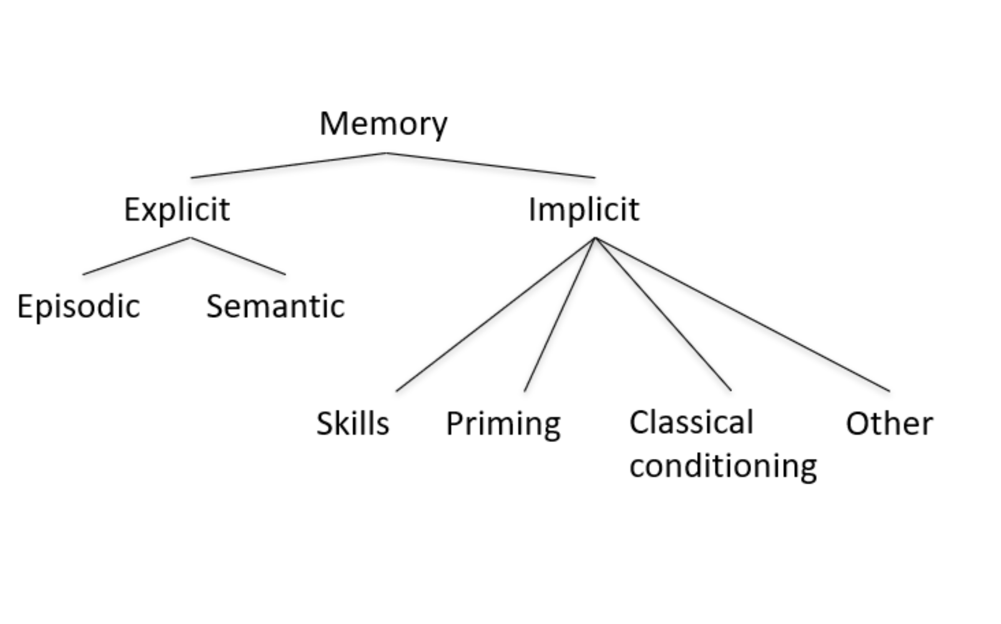

*Note*. Theroretical categorisation of memory based on the content and conscious accessibility of the information. The major explicit/implicit distinction was first put forward by Endel Tulving (1972). Figure adapted from Squire (1987).

### 2.1.2 Associative and non-associative learning

Associative learning requires learning the temporal relationship between two stimuli. For example, one stimulus reliably precedes another, or a behaviour reliably elicits a reward. Non-associative forms of learning captures learning about a stimulus itself, but not in relation to other stimuli. This typically takes the form of behavioural sensitisation or habituation. If you were to deliver a mild shock to my hand, I would withdraw it reflexively as part of the innate startle response. But with repeated administration of the shock over time, I would learn that the shock is not harmful. The size of my startle response would decrease (habituation). I have learned something about the shock, but have learned nothing about its temporal relationship with other stimuli. To translate this example to an associative form of learning, a moderate shock could be delivered after being shown a picture of a sunflower. I would learn an association between the flower imagery and the subsequent painful experience. With repeated pairings, I would display a preemptive startle response (tense muscles, squint my eyes, dip my head) to presentations of the flower alone. I have learnt a temporal association between the flower and the shock such that my body now predicts and prepares for the shock before it arrives.

Classical conditioning and operant conditioning are two frequently used forms of associative learning. Classical conditioning involves learning an association between two or more stimuli, as in the flower/shock example above. Operant conditioning differs from classical conditioning in that rather than one stimulus being paired with another stimulus, a behaviour comes to be associated with a specific outcome. For example, I learn that signing up to psychology experiments often involves being exposed to irritating stimuli. This changes the likelihood of that response being produced in the future. In other words, I stop signing up as a participant.

### 2.1.3 Maladaptive learning

The examples outline above capture learning in cases where it is beneficial for the learner. In the classical conditioning case described above, preparing for a shock by tensing my muscle tissue reduces the painfulness of the experience and minimises the chance of tissue damage. For the operant conditioning case, avoiding future experiments would mean I am exposed to less unnecessary irritants. Although these are mundane examples, we will all encounter consequential cases whereby our wellbeing and longevity is enhanced by learning from past experience. A close call when crossing a road (and the negative physiology experience that ensues) increases the likelihood of diligently looking both ways before future crossings. But learning is not always protective.

The capacity for learning leaves us vulnerable to developing maladaptive habits. Consider Rebecca’s first experience with heroine. Prior to consumption, Rebecca has heard about heroine, but only in the sense that she knows it is a harmful drug, that similar drugs are used in a medical setting, and so on. She has no prior subjective experience of its effects. After several experiences with the drug, she learns about the intense sense of euphoria that comes from its consumption. Later on, Sarah develops a strong motivation to take the drug again, especially when she sees drug associated cues (syringes, white powder etc.).

Without the capacity to form such associations, addiction would not be an issue. Sarah would fail to remember what actions led to such euphoric experiences, and no motivations would be aroused at the sight of drug paraphernalia. Addiction arises from the often useful ability to remember what past actions and events resulted in positive and negative experiences. In Rebecca’s case, the euphoria experienced while initially using the drug led to a neurological rewiring. It is as if the cognitive system used for goal pursuit has been hijacked to pursue heroine, even in the face of adverse consequences (Panksepp et al., 2002; Tan et al., 2024).

Many aspects of poor mental health, including features of depression, PTSD, and anxiety, only arise because of our ability to learn. For example, anxiety entails worry or concern over some perceived threat. The threat has not yet occurred, but to a person with anxiety, past experience of similar circumstances creates excessive fear as they imagine a similar negative outcome occurring in the future. If we can understand what biological mechanisms create associations between a context and a negative outcome, as in the case of anxiety, we can then develop methods which unpick the maladaptive associations and reduce human suffering. While we have made progress in our understanding of how memories are forged at the molecular and cellular level, there are many unknowns which constrain our ability to create useful interventions.

## 2.2 Mechanisms of memory storage

As described earlier, the process of acquiring an enduring memory involves transforming information from a temporary state to a stable state. But this is not a usual trajectory for most of the information we encounter. The most common fate is for information to be quickly forgotten. This is evolutionary sensible. Storing information takes energy and physical real estate, and attaining energy comes at a price. Every organism therefore has a small number of things about which it must study extensively and track over time. But most of the information an organism encounters, be it visual, tactile, or olfactory, is not worth storing. A gazelle cares about the scent of a cheetah, but cares not for the small beetle being crushed under its foot as it moves. While a gazelle’s brain may process information about both stimuli, it is not equally likely to store both experiences and the contexts in which they took place.

When discussing how information is stored, one becomes steeped in complex biological pathways. These pathways involve proteins interacting with other proteins, proteins interacting with DNA, and the production of new proteins. In the neurobiological literature, much of the discussion around learning takes place at the level of the synapse – a synapse being the point where two neurons interact. Typically, the axon from neuron A attaches to a dendrite from neuron B and forms a synapse. Synapses are the locus of communication in the brain. At an abstract level, learning occurs when incoming stimulation affects downstream dendritic spines such that they move through the following sequence of stages: generation, stabalisation, consolidation, and maintenance (see Rudy, 2014 for a digestible overview of each stage). Complicated mechanisms are involved in each stage of learning, and not all the components are fully understood. Despite that, the literature provides a good account of many important molecular events thought to be involved in storing information in the brain so that it can be accessed in the future.

When some new bit of information has been acquired by the brain, its physical embodiment is refered to as a “memory trace” (Asok et al., 2019; Robins, 2023; Semon, 1921). To generate this memory trace, a post-synaptic influx of calcium (resulting from stimulation by an upstream neuron A) is necessary (Cavazzini et al., 2005; Lynch et al., 1983). Once inside the pos-synaptic dendrite, calcium interacts with intracellular proteins that break down actin into smaller chunks (Lynch et al., 2007). Although actin helps give structure to dendritic spines, dissasembly is necessary to create room for more receptors into the membrane of neuron B. Adding receptors to the membrane makes the spine on neuron B more sensitive to the upstream firing of neuron A, and thus more likely to itself fire an action potential in response. This rapid change in sensitivity (potentiation) is short lived. Without further processing, the potentiated state will revert back to baseline.

Stabilisation of the memory trace requires expanding and strengthening the post-synaptic actin network to solidify the heightened sensitivity (Chen et al., 2007). The spine head is enlarged and as a result, the actin scaffolding is modified to make it less vulnerable to being disassembled in the future. In addition to actin reorganisation, cell adhesion proteins in the cell membrane help to couple the pre- and post-synaptic neurons, improving the effectiveness of neurotransmission (Huntley et al., 2002). With these two key modifications, the pencil marks of memory are laid down. But these scratchings must be committed to ink to stand the test of time.

Consolidation is where the cellulcar changes are solidified to stave off forgetting. Consolidation is unique in that it involves the production of new proteins. In response to neuronal stimulation, a number of events take place in the postynaptic neuron. One response is the activation of proteins which are able to enter the nucleus and bind to DNA. This activity leads to transcription of new molecules (messenger RNA) that will later be turned into proteins including receptors. This genomic signaling ensures new proteins are continually minted, providing a sufficient pool of receptors and other elements needed to keep the spine in a state of heightened sensitivity. But the events of consolidation are not final. The post-synaptic cell enters a maintanance stage where the supply of membrane receptors produced and inserted into the membrane remains heightened. Moreover, the typical dynamics of receptor removal and recycling is slowed. More excitatory receptors remain on the cell membrane which ensures heightened sensitivity to signals from presynaptic neurons both now and in the future.

## 2.3 Memory research in animals and invertebrates

Many organisms have been poked and prodded during our efforts to understand the mechanisms of memory. Scrub jays, a bird sporting a bold blue coat and pointed black beak, have been recurring subjects in studies investigating spatial memory. This is because of their food caching expertise (Shettleworth & Krebs, 1982). Sophisticated techniques have been used to study changes in hippocampal volume in response to caching. The possibility of season-dependent changes in hippocampal neurogenesis in caching birds has also been explored (reviewed in Pravosudov, 2007).

Rodents have featured heavily in the experimental memory literature (Ghafarimoghadam et al., 2022). Recent advances in stimulation and imaging, specifically techniques like optogenetics (Goshen, 2014) and two-photon microscopy (Kawakami et al., 2015), have enabled us to study representation of different types of memory at levels ranging from individual synapses to neuronal ensembles. Moreover, the last two decades saw a growing interest in episodic memory in rodents. In the rodent literature, episodic memory is the ability to represent the past and draw on specific encoded events in a manner akin to mental time travel (Crystal, 2022; Eacott & Easton, 2007; Tulving, 2002). Intricate tasks have been developed which enable rats to demonstrate memory for the context in which a stimulus had been previously presented, and to disentangled this from mere familiarity with the stimulus due to temporal proximity (Panoz-Brown et al., 2016). However, the existence of episodic-like memory in non-human animals remains controversial (Hoerl & McCormack, 2019; Tulving, 2005). The establishment of procedures for identifying and manipulating complex episodic memory, by optogenetic and other means, may help identify the mechanisms (synaptic or molecular) that underpin episodic memory in humans.

Research in birds and rodents has supplied decades of insights into the brain regions involved in memory. But to understand the precise structural and molecular changes that underpin the creation of memory, the field turned to invertebrates. The simplicity of invertebrate neural architecture allows researchers to account for and track the entirety of a nervous system, and to observe the functional specificity of individual neurons. However, simplicity is not the only benefit. Costs can also be significantly reduced and environmental variables are more easily controlled. Moreover, ethical concerns are diminished due to the reduced likelihood of finding meaningful sentience at this level.

Although largely unknown outside of the sciences, *Aplysia* is a celebrity among the invertebrates for its contribution to the neurobiology of learning. *Aplysia* is a marine snail with a simple nervous system. The abdominal ganglion (collection of neurons) of *Aplysia* is home to the largest known neurons in nature (Moroz, 2011). This makes it an ideal candidate for studies using electrophysiology – the approach where neural activity is recorded by inserting electrodes into cells or in the space surrounding cells. In *Aplysia*, stimulation of the siphon used for transporting water throughout the body leads to a defensive retraction of the gill (Carew et al., 1981). Repeated stimulation leads to a decrease in the intensity and length of the retraction, a simple form of non-associative memory called habituation (Pinsker et al., 1970). Admittedly, this simple form of learning is of limited relevance to human cognition. Yet, this basic adaptation in *Aplysia* served as a platform for understanding the general principles of learning from generation to consolidation and maintenance. It is thought that these stages of information processing are conserved throughout nature and underpin more complex forms of learning that are of interest to humans (Kandel et al., 2021, p. 1330).

*C. elegans* is another organism which towers above most invertebrates in terms of popularity. *C. elegans* gained prestige after it was the first organisms to have its connectome mapped (White et al., 1986). Understating the wiring of all 302 neurons in *C. elegans* allowed for a systems perspective of the nervous system. We could piece together the role of each neuron in helping the body to perform actions such as navigation, digestion, and defensive behaviours. Although the nervous system of *C. elegans* is small compared to that of mammals, it revealed principles of neuronal organisation which persist across brains of all sizes. Principles such as reciprocal inhibition to facilitate movement, computing at the level of the cell for efficiency, and minimising the total length of neuronal wire (Sterling & Laughlin, 2015). We may find comfort in distancing ourselves from so-called “lower organisms”, but nature is indifferent to our need for preeminence. Our brains may be bigger, but nature has equipped us with many of the same basic processes for learning, navigating, and operating in a complex world.

The study of invertebrates revealed that even complex behaviour can arise from a modest number of neural cells. Consider that C. elegans has less connections in its entire nervous system (~7000) than a single mammalian pyramidal neuron (Cook et al., 2019; Megı́as et al., 2001; Sterling & Laughlin, 2015). Yet, this bare-bones neuronal setup is sufficient for detecting a variety of chemical and olfactory cues, navigating the environment, escaping threats and detecting dynamic environmental signals such as temperature changes and social crowding. As we climb the ladder of complexity from *C. elegans* to more sophisticated invertebrates, the cognitive capabilities and potential for translational insights expands in turn.

### 2.3.1 Planaria as a model organism

Planaria are a broad group of invertebrates which have become a key part of several areas of research. Planaria are being used to investigate questions in regenerative biology (Karami et al., 2015), toxicology (Hagstrom et al., 2019; M.-H. Li, 2008), radioprotective materials (Ermakov et al., 2021) addiction (Raffa, 2008), and the effect of zero gravity environments on morphology (Vista SSEP Mission 11 Team et al., 2018). Planaria have built niches across many ecological contexts and can be found in salt-water and fresh-water environments, and also on land. Land dwelling planaria span up to half a meter long (Esser, 1981), whereas freshwater planaria, which are more commonly used in behavioural research, are typically less than a centimeter in length (Vásquez-Doorman et al., 2022).

Planaria are bilaterians. They display bilateral symmetry across their left and right sides (Sluys & Riutort, 2018). Planaria exhibit anterior-posterior polarity, such that their head can be distinguished from the tail in both its structure and its behavioural repertoire. While the tail end of a planarian is rather uninteresting, the head has many intriguing features. Auricles are what give the head of many planarian species a triangular shape. Auricles are thought to support the detection of food and noxious chemicals in the immediate environment (Asano et al., 1998). Eyespots, which are the most discernible feature of planaria, sit atop the dorsal surface of the head. These light-sensitive cell clusters allow planaria to detect light intensity and direction (Shettigar et al., 2017).

Of particular interest to neuroscientists, the planarian head harbors a bilobed brain which is needed to coordinate activity throughout the body (Inoue et al., 2015). This simple neural structure is of special evolutionary significance as planaria are thought to be the oldest organism to house an organised central nervous system, or what we might call a true brain (Pagán, 2014; Sarnat & Netsky, 1985). In real terms, the planarian brain lacks many features compared to the exuberance of the mammalian brain. But relatively speaking, the brain-to-body-mass ratio of planaria is similar to that of a rat (Best, 1983).

The planarian brain resembles a horseshoe (Agata et al., 1998; Sarnat & Netsky, 1985) and has been estimated to contain between twenty to thirty thousand neurons (Inoue, 2017, p. 82). The brain exhibits nine branches on each side which radiate out from the center. The lobes of the brain form thin nerve cords at their posterior end. These chords extend down the length of the body towards the tail and, together with the brain, comprise the central nervous system. The left and right nerve cords are connected by commissures which form a ladder-like structure (Sluys & Riutort, 2018).

Planarian neurons appear more similar in structure to those of vertebrates than to those of other invertebrates (Sarnat & Netsky, 1985). They feature spine-like protrusions on their dendrites (Petralia et al., 2016; Sarnat & Netsky, 1985), and contain many dendritic branches but only a single axon. Zooming in further, planarian neurons contain a variety of synaptic vesicles, such as clear and dense-core variations, which resemble those seen in vertebrate neurons (Oosaki & Ishii, 1965). Most relevant to the research described in this project, planaria produce many of the same neurotransmitters and neuromodulators that we humans’ possess. These include serotonin, dopamine, epinephrine, acetylcholine, GABA, glutamate and opioid peptides (Rawls et al., 2006; Sarnat & Netsky, 1985; Welsh & Williams, 1970; for a comprehensive review of planarian neurochemistry see Buttarelli et al., 2008).

The physiologist August Krogh posited that “You will find in the lower animals mechanisms and adaptations of exquisite beauty and the most surprising character” (1929, p. 203). The conservation of neurochemistry in planaria is noteworthy. But it is their regenerative ability that makes them worthy of Krogh’s dictum. Many planaria species undergo a natural form of fission as part of their reproductive cycle. They tear themselves in half, with each half then regrowing all the necessary parts of its basic body plan to form a complete planarian again – a form of reproductive immortality. Regeneration is not completely novel in nature. Humans can regrow skin, and salamanders can regrow amputated limbs. But what sets planaria apart from the rest of the natural world is their ability to regrow tissue for the brain and central nervous system.

Planarian regeneration is facilitated by adult pluripotent neoblast cells which are found throughout the body (Neuhof et al., 2016). After significant injury, these cells proliferate and undergo differentiation, providing the cell types needed to restore organs, membranes, and neural networks in the brain. This capability has drawn interest from medical researchers for more than a century (Child, 1941; Morgan, 1898; Reddien, 2018). By understanding the factors that control planarian regeneration, we may be able to artificially simulate these processes in humans to restore limbs or neural structures after injury. Commerical ventures are already being established in this area. Companies such as Morphoceuticals are looking to apply lessons learnt from planarian regeneration to rodents and, pending pre-clinical success, eventually humans (Pio-Lopez & Levin, 2023; Saltzman, 2023).

### 2.3.2 Review of planarian memory literature

In the 1900’s, there was still some debate regarding whether invertebrates have the cognitive means needed to learn. A skeptical approach was evident from Donald Jensen in the 1970s who posited that “no invertebrate, no matter how complex is capable of showing ‘true learning’” (quoted in Rilling, 1996, p. 591). This view established an artificial barrier separating organisms that suitably model human cognition from those that do not. Because invertebrates were overlooked, researchers tried to make progress on the neurobiology of memory using the complex nervous systems of rodents. After many years searching for the rodent engram, the collection of neurons underlying a specific learning event, this venture unearthed little of value (McConnell, 1967, pp. 2–3). A group of psychologists including James McConnell in the 1970s were aware that little progress was being made in this endeavor. The group moved defiantly away from rodents and drifted towards invertebrates. Starting with much simpler organisms would allow researchers to progress past mere descriptions and arrive at an actual understanding of the mechanisms of learning.

At first, McConnell and colleagues completed basic experiments showing that planaria could learn to associate a light (conditioned stimulus, CS) with a shock (unconditioned stimulus, US) (McConnell et al., 1959). Compared to control subjects, trained planaria would exhibit more body contractions in response to light and perform more changes of direction. But criticism arose over the lack of controls in these experiments (Travis, 1981). Later follow ups included blinding the experimenter and testing for confounding factors such as pseudoconditioning (where additional stimuli elicit the unconditioned response despite no temporal relationship) and sensitisation (an increase in responding to the CS due to repeated presentation, rather than because of its association with the US). Contrary to the expectations of psychologists at the time, evidence for learning in invertebrates accrued study after study. It was eventually impossible to deny the ability to form stable associative memories to these rudimentary creatures. McConnell and others such as Eric Kandel established definitively that invertebrates are capable of learning, retaining, and acting on information.

Forming associative memories is an impressive feat given the bare-bones layout of the planarian brain. But why pursue planaria as a model organism? Why not shift all our resources towards other sophisticated invertebrates like honeybees and fruit flies? It was the pairing of a capacity to learn with the rare ability for regeneration in planaria that sprouted one of the most peculiar branches of research to date: the investigation of memory retention after decapitation and regeneration of the brain. This unique combination allowed researchers to ask what happens if you condition a planarian then cut it in half? Does the tail, which needs to regenerate its head and central nervous system, retain any prior learning? James McConnell, alongside Allan Jacobson and Daniel Kimble were the first scientists to pose and pursue an answer to this question (McConnell et al., 1959). Across a range of different training procedures, McConnell and colleagues found that regenerated planarian tails indeed retain information. This challenged the intuition that memories could only ever be stored in the brain, at least in some instances (McConnell, 1967). Instead, through some mechanism, memories are stored or backed up outside the brain and can be reinstantiated in the new brain during regeneration.

Due to controversial studies on the mechanism of memory persistence, interest in planaria eventually waned (Rilling, 1996). Thirty years later, this area underwent a modern resurgence thanks to the work of Shomrat and Levin (2013). The authors published an important paper which used an automated training protocol to revisit the memory retention effect. Planaria, like rodents, are hesitant to approach food in the center of a novel environment (Best, 1963b). They will first explore the territory, and only then engage in consumption. As planaria become familiar with the environment through repeated trials, they begin to approach the food more quickly, demonstrating a form of recognition memory (Best, 1963b). The authors explored whether this type of memory persists in the tails of trained planaria following complete regeneration of the brain.

Over ten consecutive days, half of the planaria were fed on the novel rough surface (“familiar” planaria) while the other half were only fed on a common smooth surface (“naive” planaria). At the end of the training period, the familiar group took a significantly shorter amount of time to approach and consume the food in the rough environment. Both groups were then bisected into head and tail halves and left to regenerate for 10-14 days. The authors then looked at whether the tail regenerates of familiar planaria retained familiarity of the rough environment and thus approached food more quickly compared to the naive tail offspring. The data revealed that regenerated tail fragments from familiar planaria did approach the food more quickly, however, this did not reach statistical significance. After undergoing the same training procedure as the original planaria, the authors found that regenerated tail fragments from familiar planaria demonstrated a form of memory savings. The familiar tail regenerates became accustomed to the rough environment faster than regenerates of control planaria. This indicated that some memory trace from prior training survived brain regeneration but required repetition of the training process for the memory savings to be expressed.

More recently, Samuel and colleagues (2021) corroborated this puzzling memory retention effect. The authors used sucrose to shift the surface preference of planaria from their innate preference for a smooth surface to the sucrose-paired rough surface. After amputating the planaria and allowing time for head regeneration, it was observed that the tail halves retained the sucrose-paired rough preference, despite the newly regenerated brain never having been exposed to the rough surface. In contrast, the tail halves of control planaria – which were exposed to the rough surface but did not receive sucrose in this environment – showed the expected initial preference for the smooth surface.

Memory retention experiments pressupose that although a brain is not necessary for memory storage, it is needed to act upon the memories. For this reason, sufficient time is always alloted for the brain to regenerate. However, a recent preprint by Shimojo and colleagues (2022) challenges this assumption. They tested whether planarian tails can show retention of a conditioned response prior to regeneration of the brain. In this study, planaria were trained to associate a neutral weak UV light (conditioned stimulus) with an aversive shock (unconditioned stimulus). The shock typically causes planaria to twist their body – an unconditioned contortion response. After pairing the light with the shock, planaria will display a conditioned contortion response to the UV light alone. On the second and third day after dissection, well before the brain is thought to be reformed, the tail halves were exposed to the conditioned stimulus over a number of trials and their responses were recorded. The authors analysed the data using a deep neural network to classify behaviour. They found that most responses from the tail halves were similar to those produced by an electric shock rather than those produced by a neutral ultraviolet light. Ultimately, this suggested the tail halves retained the conditioned behaviour and were able to act on it despite lacking a brain at the time.

Rhodes and Vierick (2024) followed a similar procedure to establish conditioned negative phototaxis in planaria (moving away from light). Typically, planaria are strongly averse to blue light, mildly averse to green light, and are indifferent to red light (Paskin et al., 2014). Planaria were trained to associate a neutral red light with an aversive green light across 5 days. After conditioning, half of the planaria were bisected into head and tail halves. Three weeks later, all planaria were tested for retention of the conditioned response. Both head and tail regenerates retained the conditioned memory as well as intact planaria. Moreover, memory retention was not statistically different when comparing head regenerates to tail regenerates. This study adds to the evidence suggesting that tail regenerates can retain and act on a memory even after total loss of the brain.

There are a number of issues with the study by Rhodes and Vierick, which represent common limitiations in the planarian literature. First, the number of planaria per group was very small. Most contained just four to six subjects. Another key issue is it was not clear how the dependent variable was operationalised. For example, how much movement was necessary to qualify as negative phototaxis on a given trial? We must maintain skepticism for individual studies given their limitations. But the number of findings showing successful retention of learning through regeneration provides strong support for the phenomenon.

Classical conditioning procedures are common in the planarian literature, but some experimenters have also employed operant conditioning methods (Chicas-Mosier & Abramson, 2015; Crawford & Skeen, 1967; see Best, 1963a for a review of early studies). A simple learning procedure known as the Van Oye maze was one of the first forms of reinforcement learning in planaria (Nicolas et al., 2008; Oye, 1920; Wells, 1967). In the typical setup, planaria are housed in a beaker and a fishing line with food is suspended just below the water surface. Planaria can detect the presence of food and navigate towards it (Ash et al., 1973; Miyamoto & Shimozawa, 1985). Planaria must navigate up the wall, across the surface and down the line to reach the food. This is a low probability behaviour, but some small percentage will find their way to the fishing line and be reinforced by the food. These responders will learn to reliably carry out this behaviour when food is present in the environment. Control planaria undergo similar methods but without the food reward attached. At test, food is not placed on the rod, but is instead dissolved in the water beforehand. The dissolved food is a cue that food is available. Trained planaria are subsequently found in much greater numbers on the suspended line compared to control subjects. Across five experiments performed by Wells, an average of ~17 trained subjects were found on the line at test compared to an average of ~3 experimental subjects (reviewed in Corning & Riccio, 1970). This procedure demonstrated that planaria can be trained using reinforcement learning.

Another operant conditioning study was conducted by Corning (1966) during the height of planaria fame. Corning wondered whether operant conditioned behaviours can persist through regeneration. Using a T-shaped apparatus, planaria were trained via positive reinforcement to select their least preferred side. Reinforcement consisted of being returned to the home arena for 10 minutes after making a correct choice. After incorrect choices planaria were taken to the start of the maze for another trial. A threshold for successful learning was set at nine out of ten consecutive correct choices across trials. Planaria that met this threshold were bisected.

After a two to three week regeneration period, the regenerates (both heads and tails) were given a baseline preference test and were subsequently conditioned to criterion. Corning found that the baseline of trained tail regenerates differed significantly from the baseline of the original planaria, while untrained planaria tail regenerates did not differ from the original subjects. This suggested that the trained tail regenerates retained the prior learned preference, implying that operant conditioned behaviour can be retained outside of the planarian brain. Furthermore, the regenerates of trained planaria could also be conditioned to threshold faster than regenerates of untrained planaria. While this provided evidence of memory savings when re-exposed, it also demonstrated a form of uncued recall of the memory .

The experiments above provide adequate evidence that planaria can learn operant conditioned responses. But when considering the persistence of this behaviour through bisection and regeneration, there is very limited evidence. Much of the research on operant conditioning in planaria dates back to the mid-tweintieth century. Although historical research still holds value, modern psychological science has raised questions regarding the reliability and replicability of past experiments.

Recent evidence suggests that the psychological literature broadly considered has oversold the existence and or size of many psychological phenomena (Open Science Collaboration, 2015). Much effort is being devoted towards identifying the types of decisions which lead to unreliable results appearing in the literature (Simmons et al., 2011). Interestingly, many scientists openly admit that they have engaged in questionable research practices – design and analysis decisions which lead to untrustworthy results that fail to replicate (Gopalakrishna et al., 2022). While replication attempts may often focus on findings from the last two decades, we must also carry over this skepticism to research from the twentieth century. Especially in cases where there is only one or two reports of a given phenomenon. For this reason, we must seek to establish reliable methods for inducing operant conditioned behaviours in planaria. Furthermore, we should withhold judgement on whether learned behaviours can persist through decapitation and regeneration in planaria until the phenomenon is replicated.

### 2.3.3 Positive reinforcement of planarian behaviour

Investigators have used many different stimuli, both aversive and appetitive, in their efforts to condition planaria. One of the most common appetitive stimuli in the planarian literature is cocaine which acts primarily on the dopamine transporter. Importantly, these receptors are abundant in planaria (Algeri et al., 1983; Buttarelli et al., 2008). Cocaine is a cost-effective tool for conditioning given the small quantity needed to reward planaria. But there are some concerns that require consideration when administering cocaine in behavioural tasks. For example, cocaine induces strong effects on locomotion and atypical behaviours at some doses (Pagán et al., 2013; Rawls et al., 2010).

Cocaine exerts it agonistic effects by blocking reuptake of dopamine through the dopamine transporters. In humans, this results in more dopamine activity in the synapse and therefore altered neural activity in downstream neurons, particularly in the meso-limbic pathway connecting the ventral tegmental area to the nucleus accumbens (Nestler & Lüscher, 2019). This agonistic effect is linked to the high that cocaine users experience, an effect shared by all drugs of abuse (Pierce & Kumaresan, 2006). Cocaine also acts on serotonergic and noradrenergic transmission by blocking their respective transporters (Galli et al., 1995; Mateo et al., 2004). The noradrenergic effects are thought to stimulate the sympathetic nervous system by blocking reuptake of noradrenaline and decreasing sympathetic nerve discharge, resulting in effects such as increased blood pressure and heart rate (Freye, 2009; Jacobsen et al., 1997; Nestler & Lüscher, 2019).

Amaning-Kwarteng et al. (2017) explored the establishment and extinction of a cocaine-reinforced texture preference. They found that planaria can be conditioned using cocaine to shift their surface texture preference from smooth to rough and that this preference can be extinguished (reverted back to the original preference) after repeated exposure without reinforcement. Subsequently, exposure to a bath of cocaine was enough to reinstate the conditioned preference when given free access to both surfaces.

Building on prior work dating back to the 1960’s (Needleman, 1967), Jawad, Hutchinson & Prados (2018) investigated addiction like behaviour in planaria through conditioning, extinction and tolerance. The experiment successfully demonstrated a conditioned place preference (CPP), extinction of the preference, and context specific tolerance. Of particular significance, this work demonstrated that sucrose induced CPP requires dopaminergic activity. Administration of a dopamine D1 antagonist during conditioning blocked acquisition of CPP but did not interfere with context specific tolerance. An interesting dissociation that may have implications for understanding addiction in humans.

Understanding the molecular and circuit dynamics underpinning addiction may allow us to interface with the brain so as to reduce maladaptive behaviours. Currently, therapies focus on top down strategies. People are coached to recognise their thoughts and emotions related to drugs and to manage them rather than act on them. However, if the chemistry and structural wiring of the brain change during the acquisition of an addiction, top down strategies may be inadequate. bottom up therapies involving a change of the bodies chemical and molecular milieu may support the unraveling of these harmful brain adaptations (Chodkiewicz, 2023). We are not in a position to experiment freely with bottom-up interventions in humans or other mammals. In place of that, planaria enable us to pursue a deeper understanding of the chemical and molecular changes underlying habit formation and the identification of targeted interventions to reduce future drug seeking behaviour.

## 2.4 Unresolved questions

In the first half of the 20th century, there was doubt regarding whether invertebrates can learn. But as we look back nearly a century later, we have gathered ample evidence that planaria and many other invertebrates can form long-lasting memories (Amaning-Kwarteng et al., 2017; Samuel et al., 2021; Wells, 1967). Planaria are an especially useful organism given their ability to learn and their unique ability to regenerate. As has been shown with conditioning procedures, there is now evidence that memory can be successfully retained outside of the brain (Shomrat & Levin, 2013). The persistence of basic associative memory through regeneration is remarkable. But a more compelling finding that would truly shake our fundamental understanding of memory storage mechanisms would be the persistence of complex behavioural responses.

An acquired texture preference is a valid form of learning. But it is far removed from the memories that concern us in our day to day lives. In contrast, learning shaped by a reward better reflects the intentional learning we associate with intelligence and meaningful behaviour in humans. If complex memories formed by operant conditioning can persist in planaria despite complete loss of the brain, this may have profound implications for the way we view memory storage and retrieval in humans. This project aims to extend the phenomenon of memory retention through regeneration shown for classical conditioning to an operant conditioned behaviour.

Shomrat and Levin (2013) observed that familiar tail regenerates did not initially show evidence of memory retention. However, it was clear that their performance on the task improved more rapidly than controls when they were exposed to the training procedure. Some fragment of memory for the context must have survived outside the brain. The authors showed this memory benefited future performance after reexposure to the training procedure. What remains unknown is whether retraining is the only process that supports reinstantiation of the previously aquired memory. Could it be that other contextual cues, such as exposure to the reinforcer alone, are sufficient to bring back memories acquired before decapitation?

The results of Shomrat and Levin (2013) suggested the memory trace lay dormant and failed to be reactivated at first. After exposure to the same training procedure that lead to the original memory formation, the dormant trace was then reawakened. This phenomenon of memory reactivation after prior failures parallels behaviour reinstatement in addiction research. After successfully training an animal to lever press for a reward such as cocaine, the lever press response can be extinguished by allowing the animal to repeatedly engage in the behaviour without being rewarded (Wit & Stewart, 1981). Eventually the animal will stop performing the conditioned response when the lever is presented. However, if the animal is exposed to the reinforcer before being placed back in the operant chamber, the lever pressing behaviour will spontaneously return (Wit & Stewart, 1981).

With respect to both phenomena, the memory is either not accessible or is not acted upon, and requires exposure to the right stimulus to be reactivated. Although extinction and reinstatement of drug seeking behaviour has been modeled in planaria (Amaning-Kwarteng et al., 2017), no experiments have explored whether a reinstatement procedure can also be used to reactivate memories which are dormant after decapitation and regeneration. The phenomena of savings demonstrates some memory trace is retained in the brainless tail half. Perhaps this trace can be reactivated without the need for retraining by instead exposing the tail regenrate to the reinforcing stimulus. This project will therefore investigate whether memory stored outside the brain behaves like an extinguished memory such that exposure to the reinforcer is sufficient to reinstate the memory trace.

# 3. Experiment 1

Experiment 1 aimed to determine an appropriate dose of cocaine that would be rewarding to planaria while not drastically altering their their locomotive behaviour. Cocaine has been frequently used to classically condition planaria and to investigate its toxicity (Amaning-Kwarteng et al., 2017; Hutchinson et al., 2015; Palladini et al., 1996; Raffa & Desai, 2005; Tallarida et al., 2014). Conditioning studies have used doses ranging from 1μM (Hutchinson et al., 2015) to 80μM (Raffa et al., 2005).

Investigators have observed that some planaria species are more amenable to conditioning procedures than others (Mueller & Levin, 2002; Samuel et al., 2021). Differences in the behaviour and responses of planarian species have been observed in response to several types of stimuli (Cochet-Escartin et al., 2015; DeBold et al., 1965). The species used throughout this project likely differs from those used elsewhere in the literature and may in fact be a species indigenous to New Zealand. For this reason, it is important to identify a suitable dose of cocaine which does not significantly alter motility.

### 3.0.1 Colony maintenance

Due to restrictions on importing identified species such as *Schmidtea mediterranea* into New Zealand, local planaria were sourced from a local stream within Wellington, New Zealand. Given the basic characteristics of the planaria (colour, head shape etc.) it is thought that there is a combination of Cura and Neppia species – both of which are commonly found in New Zealand waterways. We intend to perform genomic analysis at a later date to confirm the species identity. Prior to collection for each experiment, planaria were housed in a 50 liter glass aquarium with internal filtering. The aquarium contained a natural ecological environment (rocks, snails, algae etc.). The tank water (referred to as “planaria water” hereafter) was maintained with Prime – a concentrated water conditioner. The room containing the aquarium was maintained at 23°C. The planaria were fed between one and three times a week, with meals consisting of [describe food source]. The colony was maintained on a 12-hour light/dark cycle with lights on at 9:30am till 9:30pm. For experiments lasting more than one day planaria were housed in 12-well plates with 2ml of planarian water (changed daily).

### 3.0.2 Handling

Planaria were handled using different techniques for different circumstances. When removing planaria from their 12-well-plate, a filbert (medium length flat) paintbrush was preferred. However, when moving planaria between petri dishes and the y-maze, a fine artist’s paintbrush was preferred. In other cases, such as when planaria would sit in the middle of the y-maze divot, a plastic transfer pipette with the tip cut off was used. Planaria were gently handled throughout their lifespan. Rough handling was suspected to have caused a high mortality rate during pilot experiments.

### 3.0.3 Materials and Procedures

Plastic petri dishes with a diameter of 5.5cm were used to assess motility. Petri dishes contained a final solution of 8ml, made up of planaria water for control subjects and cocaine hydrochloride (Sigma Aldrich, United States??-confirm) mixed with planaria water for experimental subjects. Planaria locomotion was captured using an OPPO A17 smart phone and the videos were imported into EthoVision (Noldus Information Technologies, Wageningen, the Netherlands) for motility tracking. When subjects were not visible due to being occluded by a shadow or dish wall (~10% of frames on average across all subjects). Missing data were interpolated using the interpolation feature in EthoVision. This imposes a direct line from the subjects last location to the next observed location to determine the distance traveled.

60 planaria were used in this experiment. Planaria were assigned to one of six dose conditions based on those commonly used in the planarian literature. This included 0, 1, 5, 10, 20 and 100μM (*n* = 10 per condition). Subjects were run across twelve recording sessions[1]. Subjects were collected from the breeding tank on the day of data collection. Within each session, subjects were randomly allocated to their condition using a freely available [random number generator](https://stattrek.com/statistics/random-number-generator#table).

Each dose-response session lasted 15 minutes. Prior to the first recording session of the day the drug concentrations were achieved by mixing cocaine (dissolved in distilled water) with planarian water to reach a final solution of 8ml. Each solution was mixed and allowed to sit for several minutes to ensure diffusion of the drug. Planaria were picked and assigned to a condition from a large pool prior to the session. A planarian was picked up and a randomly generated number sequence was used to determine which condition it was assigned to. The recording began once all five subjects were in their respective dishes. After completing a single trial, planaria were rehoused in a large tank and were not used for any subsequent experiments in this manuscript.

Figure 2 shows the recording station. Five petri dishes were positioned on a white acrylic sheet. Recording sessions took place under red light, with the light positioned 36cm above the dishes. The dishes were aligned in a 2x3 grid, with a gap left in the top middle position. The overhead light was centered here to minimise shadows cast over the dishes – this was important for digital tracking accuracy. Each drug concentration was rotated across the 5 grid positions between trials to control for any effects of lighting angle.

Figure 2

Dose response apparatus

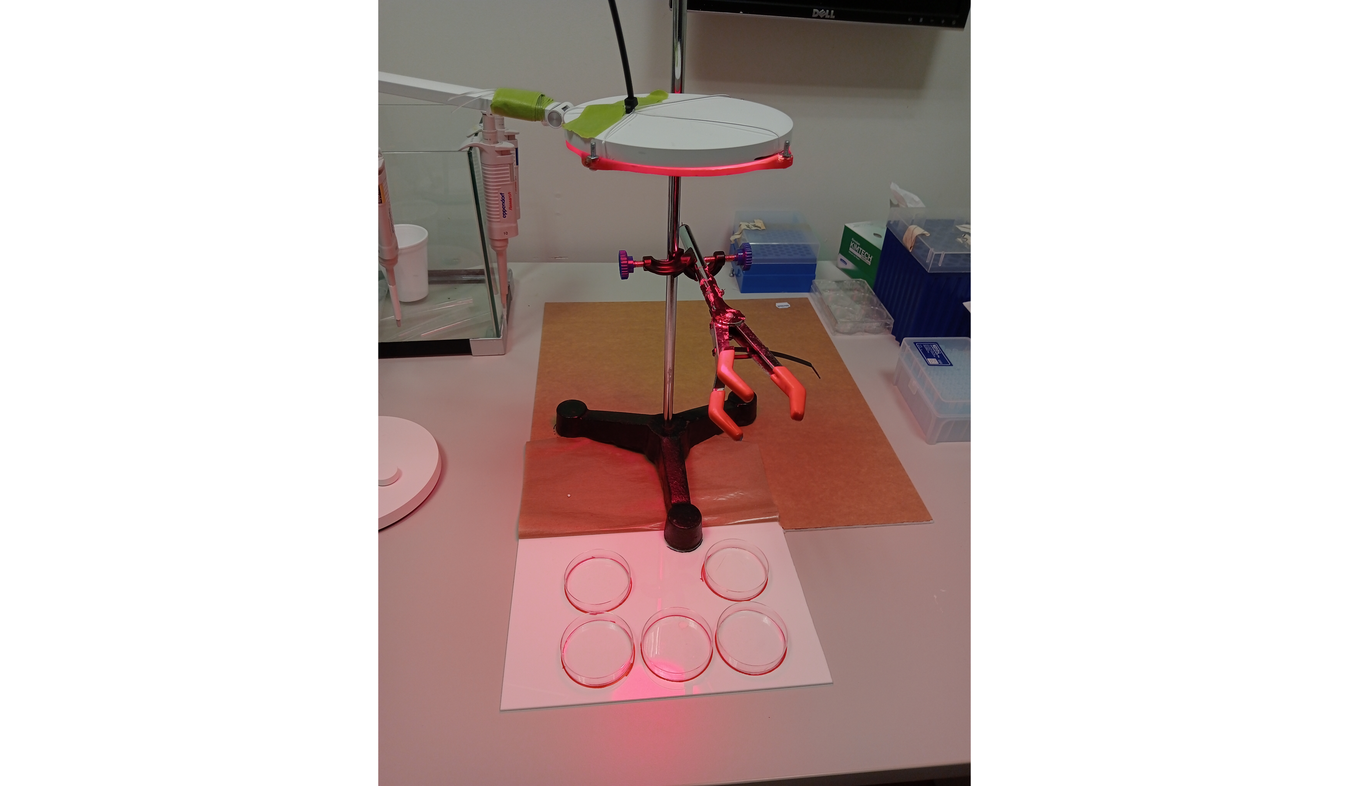

### 3.0.4 Results and discussion

Figure 3 depicts the distance moved by planaria across the six conditions. Prior to performing any statistics, the assumptions of normality and homogeneity of variances were tested. Levene’s test for homogeneity of variances suggests there were equal variances across conditions (F = 1.95, *p* = .101). The Shapiro-Wilk test indicated that the data were not normally distributed (W = 0.935, *p* = .003). Due to violation of the assumptions of ANOVA, a Kuskal test was used to evaluate group differences. The results show a statistically significant effect of condition on distance moved (χ2 (5) = 11.3, *p* = .045). An exploratory post-hoc Dunn’s test was carried out to determine the group differences. The results indicated that the 100μM group differed significantly from several other groups: control (*p* = .006), 5μM (*p* = .002), 10μM (*p* = .003), and 20μM (*p* = .016). No other significant differences were found.

Figure 3

Plot of planarian motility by condition

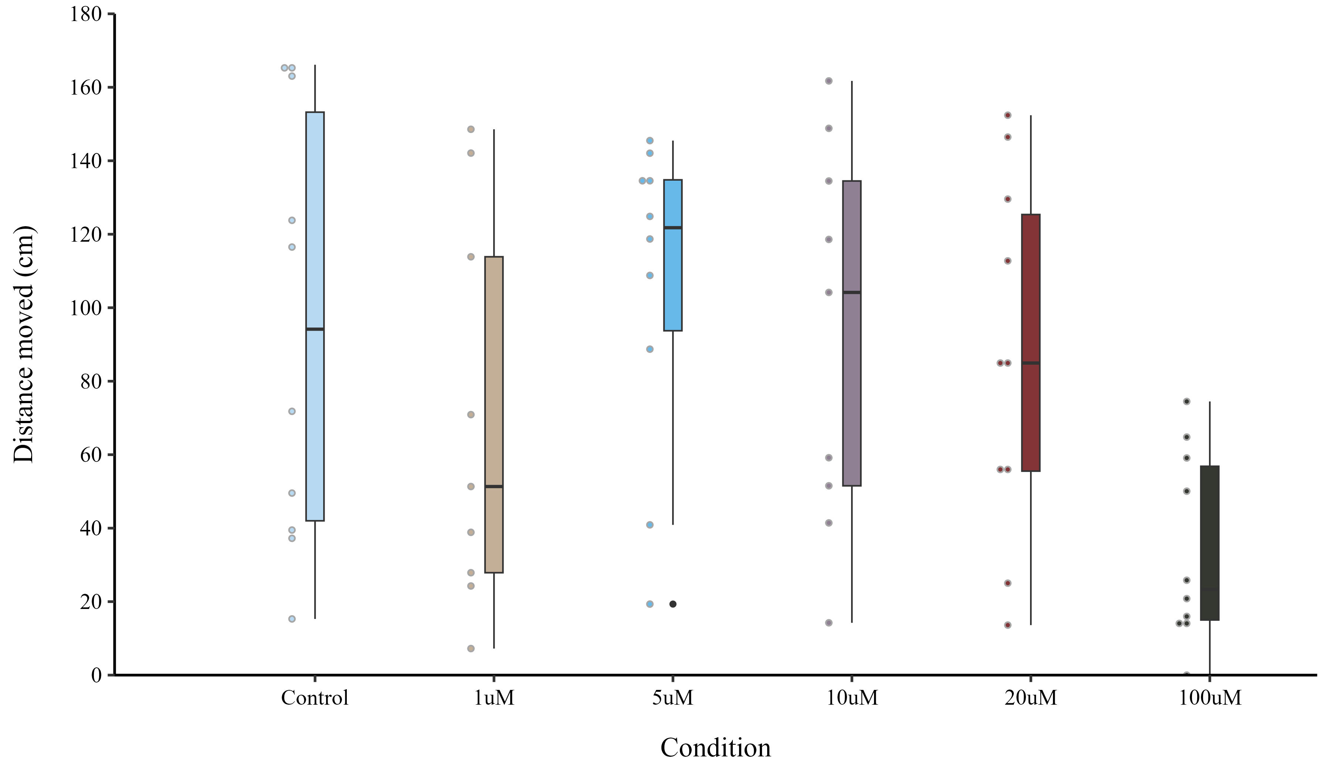

*Note*. Box and whisker plot of distanced moved by planaria over the 15-minute recording interval. Black bars indicate the mean distance moved for each condition.

The results in Figure 3 convey the variability of planarian behaviour. All conditions had at least one subject which moved less than 30cm over the 15 minute recording, and all groups had at least two subjects that moved more than 140cm. Experimenter observations indicate that when placed in the recording dish, some planaria would move initially, and then come to rest within a few minutes at a spot on the wall. They would remain here without meaningful movement for the remainder of the recording. Although the 1μM group did not differ significantly from the control group, there is a curious grouping of planaria in the 1μM condition below 60cm. Consistent with this, Hutchinson et al. (2015) observed a significant decrease in motility during exposure to 1μM of cocaine but not to 10μM when compared to a control group. No potential explanation was offered for this unusual curvilinear pattern.

The results suggest any dose between 1μM and 20μM could be used for conditioning without systematically affecting planaria motility. It was also necessary to select a dose that was sufficiently rewarding for planaria. A range of doses have been used to successfully condition planaria in CPP paradigms. These procedures typically involve low doses such as 1μM (Hutchinson et al., 2015), 5μM (Amaning-Kwarteng et al., 2017) or 10μM (Hutchinson et al., 2015). It is worth noting in the case of CPP exposure time per trial is relatively long, on the order of 15-20 minutes. Whereas in the operant conditioning paradigm proposed in Experiment 2 of this project, exposure time would be just 3 minutes. To adjust for the smaller absorption window compared to CPP experiments, the larger 20μM concentration was chosen for experiment 2.

Alongside total motility, we were able to inspect how planaria motility changed over the recording interval. We observed that planaria moved more at the start of the session compared to the end, with a gradual decrease in the distance moved with each passing minute (see Figure 4). An exploratory Welch’s two sample t-test found a significant difference between the time traveled in the first minute (M = 7.58, SD = 3.29) compared to the 15th minute (M = 4.59, SD = 3.95), with subjects travelling significantly further during minute 15 (t(59) = 6.2, *p* < .001). In future dose-response assessments, shorter recording sessions may suffice to assess dose-response curves.

Figure 4

Plot of planarian motility across recording interval

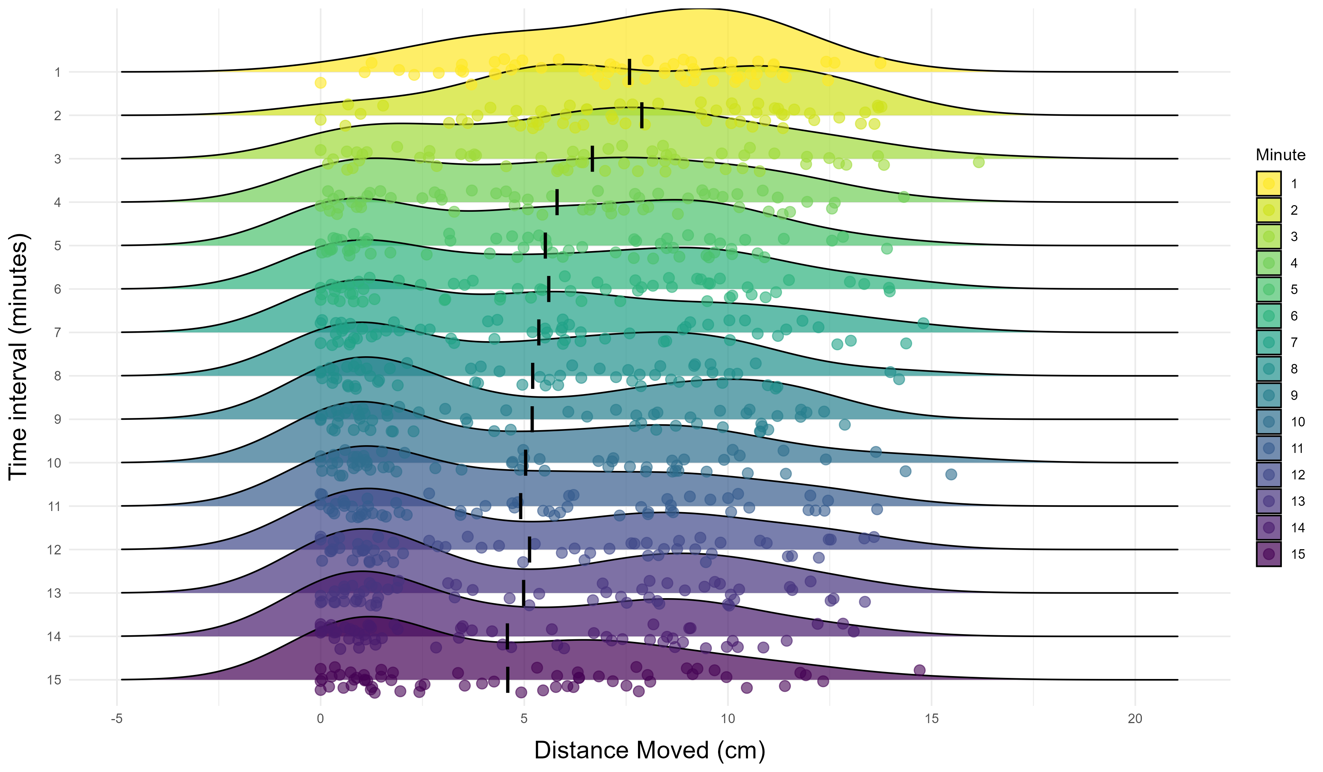

*Note*. Ridge plot of distanced moved by planaria during each minute interval. Each ridge shows the distance distribution for all subjects during the minute interval. Black bars indicate the mean distance moved for the whole sample (treatment and control subjects).

## 3.1 Experiment 2

Prior research has demonstrated the capacity for learning in planaria by way of classical conditioning. Moreover, it has been further shown that classically conditioned memories can be retained after decapitation and regeneration of the brain. But the capacity for complex memories shaped by operant conditioning to persist despite losing most of the central nervous system has not been definitively shown. As a first step towards testing retention of an operant conditioned memory through regeneration, we needed to first establish the capacity for operant learning in this species of planaria. This experiment was preregistered prior to data collection and can be found online at [Open Science Framework](https://osf.io/tq7u4/?view_only=9c794dd942fb4a54b6a986c0a893fe46) and at [PsycArchives](https://www.psycharchives.org/en/item/d6109ed1-9aab-467b-b981-e009be95f308).

### 3.1.1 Materials and Methods

Sixty planaria were used (treatment, *n* = 30; vehicle, *n* = 30). This experiment had four stages: baseline, conditioning, test, and reinstatement Figure 5 . During baseline and conditioning trials two planaria were run concurrently in separate Y-mazes [*photo to be inserted later*]. Each maze was filled with 1.8ml of planaria water. Six planaria were used per run, wherein they completed either six (baseline) or four trials per day (conditioning) with an intertrial interval of approximately 15 minutes. At the start of each session six planaria were moved into holding petri dishes. At the start of a trial, two planaria were transferred to the middle of the maze runway using a paintbrush. A timer was stared once the planarian was placed in the runway. Planaria were given three minutes to enter one of the arms [2]. Once a planarian had entered an arm, the plug was inserted to stop liquid moving between compartments, after which 0.5ml remained in each arm. A planarian was considered to have entered the arm when the plug could be safely inserted without touching the planarian.

When treatment subjects entered the active arm, 43.5μL of cocaine solution was pipetted near the center of the arm to achieve a 20μM concentration. If the inactive arm was selected, an identical volume of distilled water was pipetted near the center of the arm. After administration, the timer was restarted and three minutes were given for absorption. For control subjects, entry into either arm resulted in 43.5μL of distilled water into the arm. If a subject failed to enter an arm, the plug was inserted and 43.5μL of distilled water was pipetted into the runway and then three minutes were given. The runway light was on throughout the duration of the trial. At the end of a trial, planaria were gently removed and placed back into their holding dish.

The memory retention test took place 14 days after conditioning Figure 5. At test, six planaria were used per run. Three planaria were run concurrently in three separate Y-mazes. Planaria were given three minutes to enter an arm. Once a decision was made, the plug was inserted and planaria were left for approximately 60 seconds before being moved back to the holding dish. No additional liquid was added during test trials. The next group of three planaria would then begin their first test trial. The inter trial interval was approximately six minutes and thirty seconds. A reinstatement procedure was coarried out the following day. For the reinstatement phase, the procedure was identical to the test stage with the only additional step being drug exposure before the first trial. At the start of a run, the planaria were placed in a 20μM 8ml solution of cocaine diluted in planaria water for 10 minutes. At the end of the exposure interval, planaria were moved individually into a Y-maze to begin their first trial. Planaria were only exposed to cocaine prior to the first reinstatement trial.

There were three exclusion criteria identified in the experiment preregistration. The exclusion criteria were: A) failing to complete at least four of the six baseline trials; B) failing to complete at least two trials on consecutive conditioning days; C) failing to complete at least four of the last six trials. We attempted to replace all subjects excluded due to criterion A. However, due to time constraints, of the 18 that failed to meet this criterion, only 13 could be successfully replaced. Five subjects could not be replaced and so started conditioning despite having completed only two or three baseline trials. Thirteen subjects met criterion B or C and were excluded from the data analysis. There were no exclusion criteria set for test and reinstatement days. However, some subjects died in the waiting period, or demonstrated greatly impaired behaviour at test or reinstatement. Because of this, some subjects contributed data to baseline and endpoint, but not test or reinstatement, so the number of subjects differs across experimental phases.

three custom Y-mazes were used for this experiment. Mazes were laser etched into 80x80mm plastic squares. Each maze contains a 27mm long runway, and two arms each 25mm long. All compartments were 6mm wide and all walls were 6.5mm high. At the intersection between the runway and the arms, there is a small divot on the floor of the maze. This allows a 7mm diameter plug to be inserted to trap liquid in the arms and enable controlled drug administration. The maze floor contained subtle lines as a result of the etching process. At the base of the runway there was a small externally powered white light (~20 lux) which was fixed into the plastic. Light is an aversive stimulus which induces negative phototaxis and therefore discouraged planaria from resting at the start of the runway.

Figure 5

Graphical timeline of Experiment 2

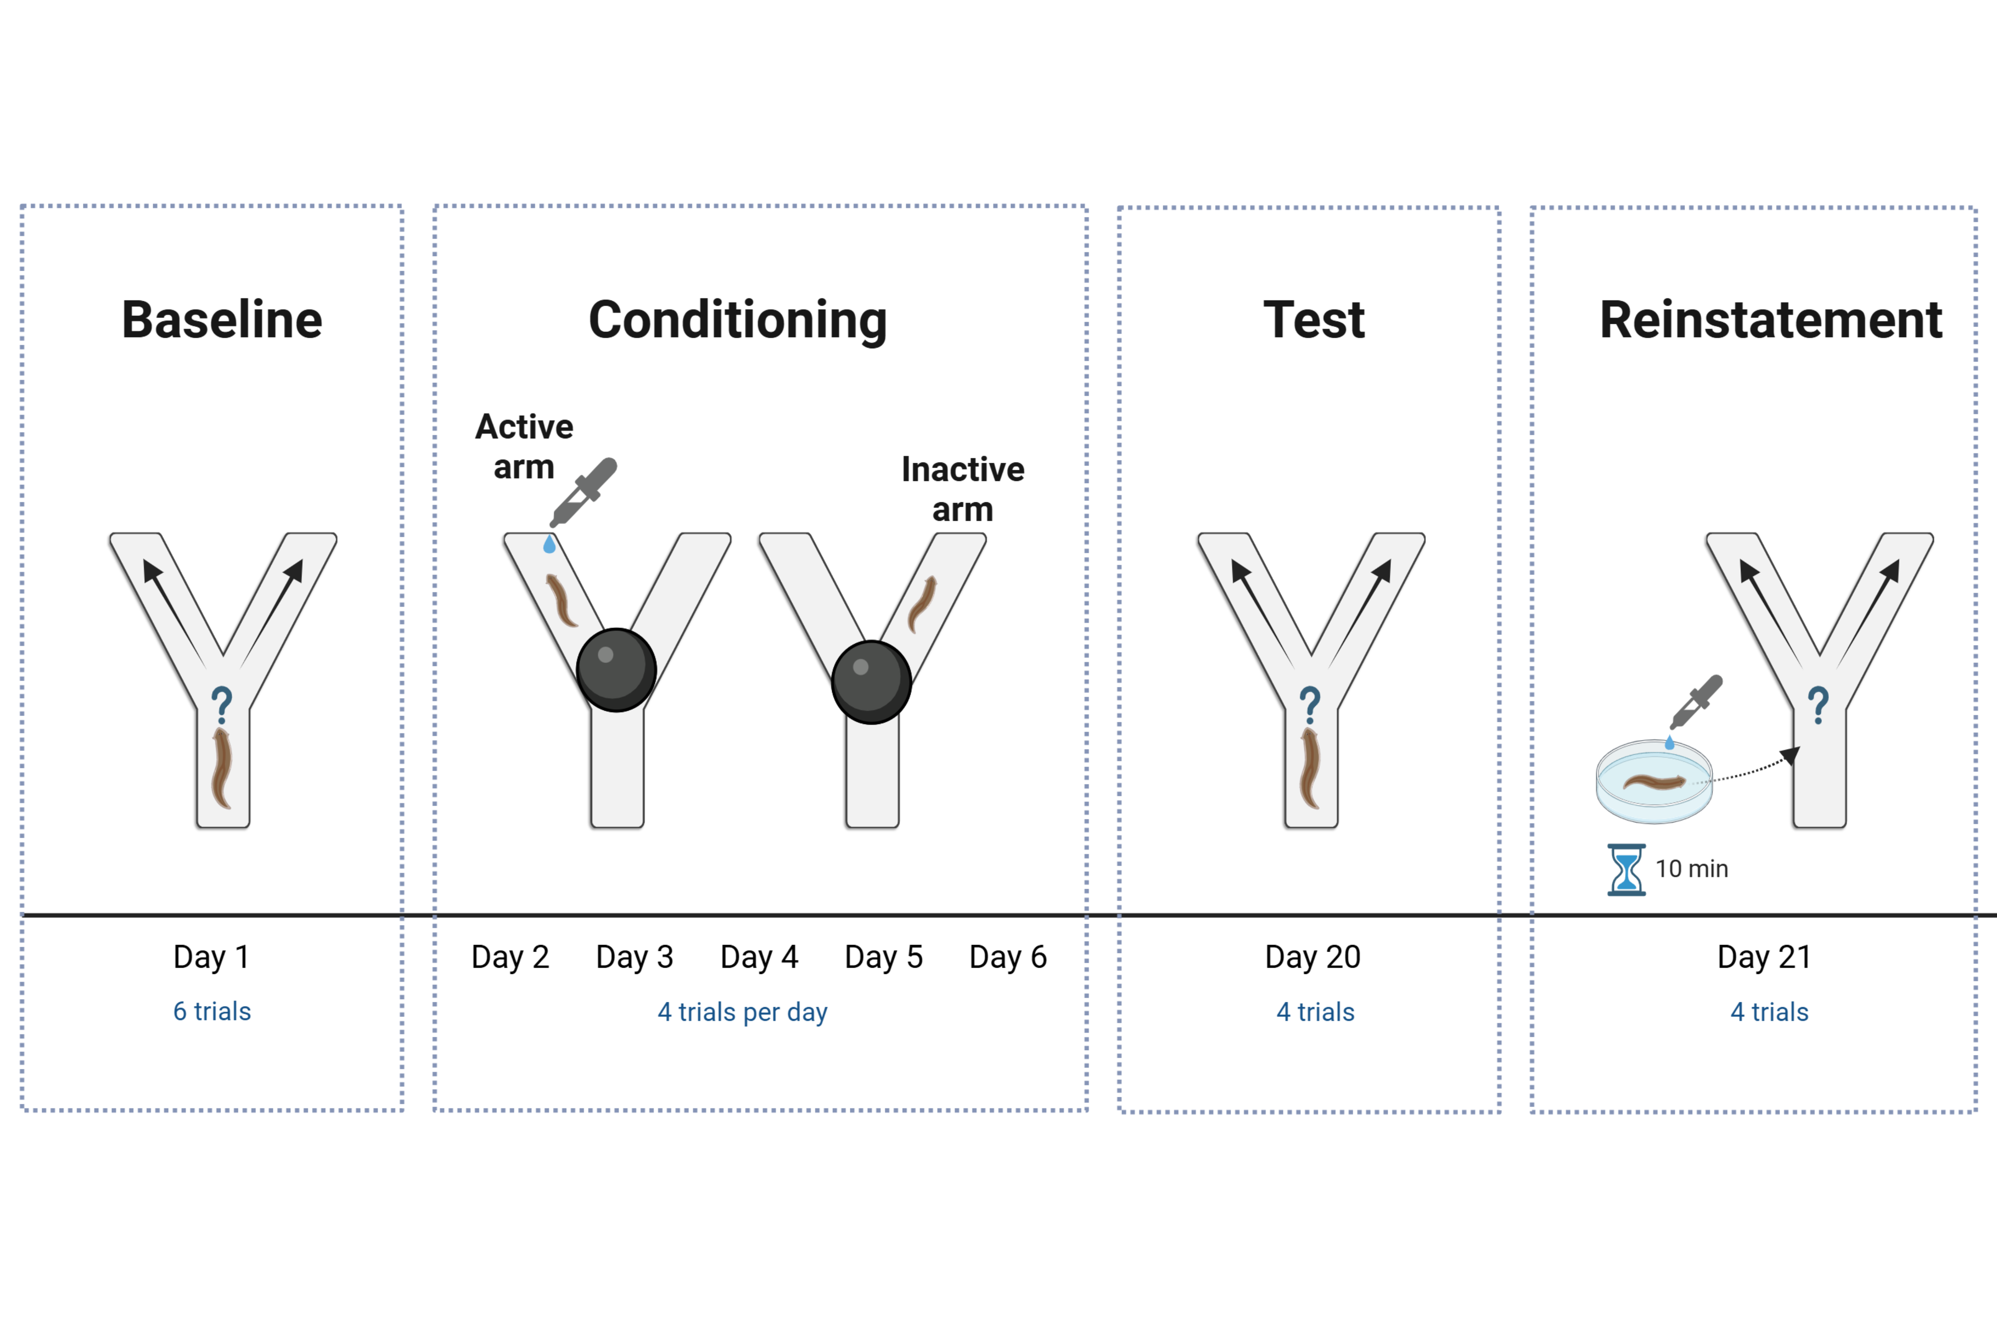

### 3.1.2 Results and discussion

Figure 6 shows the average percentage of trials where subjects entered the active arm across four time points: baseline, endpoint, test, and reinstatement. A generalised linear mixed effects model with family set to binomial was fitted in R using the lme4 package (Bates et al., 2015). Subject ID was set as a random effect, with condition, time point and the interaction term as fixed effects. Pairwise comparisons with a Bonferroni correction were carried out using the emmeans package in R (Lenth, 2024). A Type III ANOVA was conducted using the using the car package (Fox & Weisberg, 2019) to identify whether there was a significant effect of condition or time, or an interaction effect.

We did not detect a significant effect of condition (χ2 (1) = 0.773, *p* = .379). The results indicated a significant effect of time (χ2 (3) = 35.5, *p* < .001) and a significant time*condition interaction (χ2 (3) = 10.2, *p* = .017).

Post-hoc pairwise comparisons were carried out using estimated marginal means with a Bonferroni corrections applied to account for multiple comparisons. Comparisons looked at within group differences in response probability across the four phases and between group differences at each stage. The results indicated that there were two within-group differences for the control subjects: endpoint differed significantly from baseline (*h* = 0.56, *p* < .001), and test differed significantly from endpoint (*h* = 0.65, *p* < .001). There were three within-group differences for the treatment subjects: endpoint differed significantly from baseline (*h* = 0.4, *p* = .002), test differed significantly from baseline (*h* = 0.35, *p* = .044), and reinstatement differed significantly from endpoint (*h* = 0.36, *p* = .035). A significant between-group difference was found in the preference score between treatment and control subjects at test (*h* = 0.48, *p* = 0.004).

Figure 6

Mean Active Arm Preference Across Experimental Phases

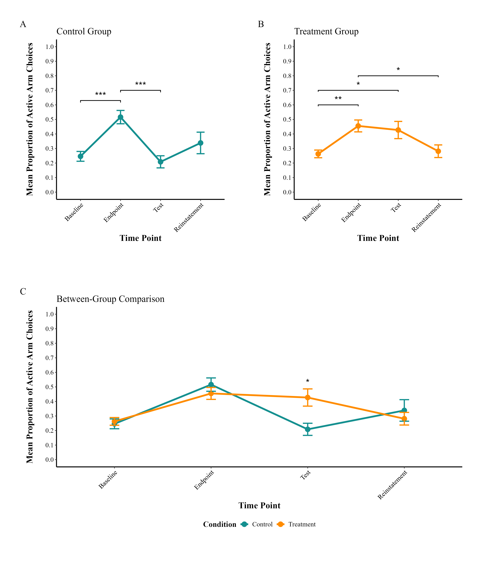

*Note*. Changes in Y-maze active arm preference across experimental phases. The baseline phase included 6 trials, conditioning endpoint included the final 6 trials, and both test and reinstatement phases included 4 trials each. A) Control group showed significant differences in active arm selection between baseline and endpoint (p < .001), and between endpoint and test (p < .001). B) Treatment group demonstrated significant differences between baseline and endpoint (p < .01), baseline and test (p < .05), and endpoint and reinstatement (p < .05). C) Between-group comparison revealed significantly different active arm preferences during the test phase (p < .01). Error bars represent standard error of the mean. * = p <.05; ** = p <.01; *** = p <.001.

Looking at the results in Figure 6B, subjects in the treatment group appear to have been successfully conditioned. These subjects were more likely to choose the active arm at the end of conditioning (endpoint) compared to baseline. Moreover, this preference was maintained for two weeks as evident by the heightened preference at test. Despite the increase in preference persisting for two weeks, when tested the next day during the reinstatement procedure the preference had returned to baseline levels.

Figure 6A indicates the control group demonstrated a similar increase in preference for the active arm despite receiving no reinforcement. However, in contrast to the treatment group, the change in preference returned to baseline levels when tested two weeks after conditioning. This highlights the natural variability in planaria behaviour over time.

The between groups comparison seen in Figure 6C shows a significant difference between groups at test. It may be that the preference stability shown by the treatment group is evidence of true learning as opposed to the natural variability of behaviour seen in the control group. This could explain why the treatment group effect remained even after two weeks, while the control group effect diminished back to baseline. But the reinstatement results constrain this rationale. If the conditioned behaviour was able to persist for several weeks, there is little reason to expect it would be extinguished rapidly but fail to show the expected effect of reinstatement. Overall, the results are inconclusive regarding whether planaria can learn the y-maze procedure. Future refinements of the maze design may increase the rate of successful learning.

This experiment also considered planaria response times for each trial. We hypothesised that even if planaria cannot learn to make the correct decision, they may demonstrate increased motivation due to being aware that a reward is available. This could be inferred from faster responding in the treatment group compared to the control group. The response time data across the four experimental phases are shown in Figure 7.

Figure 7

Mean Decision Latency Across Experimental Phases



*Note*. Mean time taken to make a response across phases and between conditions.

The decision latency data were analysed with a linear mixed-effects model using the lme4 package for R (Bates et al., 2015). The model included fixed effects of condition, time point, and an interaction term. Subject ID was set as a random effect to account for repeated measures. The decision time data were log-transformed. Type III ANOVA was conducted using the car package (Fox & Weisberg, 2019) to test for statistical significance of the fixed effects. Pairwise comparisons with a Bonferroni correction were carried out using the emmeans package in R (Lenth, 2024).

The ANOVA results revealed a significant effect of time (χ2 (3) = 24, *p* < .001), but failed to show a significant effect of condition (χ2 (1) = 0.266, *p* = .606). No time*condition interaction effect was found (χ2 (3) = 1.88, *p* = .598).

Post-hoc pairwise comparisons were carried out using estimated marginal means with Bonferroni corrections applied to account for multiple comparisons. Comparisons looked at within group differences in decision latency across the four phases and also looked at between group differences at each phase.The results indicated that there were two within-group differences for the control subjects: test differed significantly from baseline (*d* = .56, *p* < .001) and test different significantly from endpoint (*d* = .54, *p* < .001). There were four within-group differences for the treatment subjects: test differed significantly from baseline (*d* = .85, *p* < .001), reinstatement differed significantly from baseline (*d* = .67, *p* < .001), test differed significantly from endpoint (*d* = .53, *p* < .001), and reinstatement differed significantly from endpoint (*d* = .40, *p* = .007). There were no significant differences between groups.

The decision latency data do not support our hypothesis. Rather than decision latency decreasing over the experimental phases for the treatment group, there was no change for either treatment or control groups between baseline and endpoint. Moreover, at test both groups showed increased latency for decision making. It was observed that planaria became smaller across the duration of the experiment. This occurs as a result of being deprived of food for prolonged periods and is an adaptive response by planaria (Pascual-Carreras et al., 2020; Thommen et al., 2019). Although some research suggests planarian locomotor velocity is independent of body size (Raffa et al., 2001), this may only hold for between subjects comparisons during short experiments. In this case, when the size of planaria changes over time, it may be a sign of impaired health and low energy availability. While it may be reasonable to expect decreased decision latency across the first few conditioning days, as the experiment draws out, any effect of motivational may be diminished by the effect of starvation and energy depletion. It could be that there was no increase in motivation among planaria, or more likely, response latency is not a suitable measure of planaria motivation.

# 4. References

Agata, K., Soejima, Y., Kato, K., Kobayashi, C., Umesono, Y., & Watanabe, K. (1998). Structure of the Planarian Central Nervous System (CNS) Revealed by Neuronal Cell Markers. *Zoological Science*, *15*(3), 433–440. <https://doi.org/10.2108/zsj.15.433>

Algeri, S., Carolei, A., Ferretti, P., Gallone, C., Palladini, G., & Venturini, G. (1983). Effects of dopaminergic agents on monoamine levels and motor behaviour in planaria. *Comparative Biochemistry and Physiology Part C: Comparative Pharmacology*, *74*(1), 27–29. <https://doi.org/10.1016/0742-8413(83)90142-1>

Amaning-Kwarteng, A. O., Asif-Malik, A., Pei, Y., & Canales, J. J. (2017). Relapse to cocaine seeking in an invertebrate. *Pharmacology Biochemistry and Behavior*, *157*, 41–46. <https://doi.org/10.1016/j.pbb.2017.04.008>

Asano, Y., Nakamura, S., Ishidas, S., Azuma, K., & Shinozawa, T. (1998). Rhodopsin-Like Proteins in Planarian Eye and Auricle: Detection and Functional Analysis. *Journal of Experimental Biology*, *201*(9), 1263–1271. <https://doi.org/10.1242/jeb.201.9.1263>

Ash, J. F., McClure, W. O., & Hirsch, J. (1973). Chemical studies of a factor which elicits feeding behaviour in Dugesia dorotocephala. *Animal Behaviour*, *21*(4), 796–800. <https://doi.org/10.1016/S0003-3472(73)80106-X>

Asok, A., Leroy, F., Rayman, J. B., & Kandel, E. R. (2019). Molecular Mechanisms of the Memory Trace. *Trends in Neurosciences (Regular Ed.)*, *42*(1), 14–22. <https://doi.org/10.1016/j.tins.2018.10.005>

Atkinson, R. C., & Shiffrin, R. M. (1968). *Human Memory: A Proposed System and its Control Processes* (K. W. Spence & J. T. Spence, Eds.; Vol. 2, pp. 89–195). Academic Press. https://doi.org/<https://doi.org/10.1016/S0079-7421(08)60422-3>

Barron, A. B., Hebets, E. A., Cleland, T. A., Fitzpatrick, C. L., Hauber, M. E., & Stevens, J. R. (2015). Embracing multiple definitions of learning. *Trends in Neurosciences (Regular Ed.)*, *38*(7), 405–407. <https://doi.org/10.1016/j.tins.2015.04.008>

Bates, D., Mächler, M., Bolker, B., & Walker, S. (2015). Fitting Linear Mixed-Effects Models Using lme4. *Journal of Statistical Software*, *67*(1), 1–48. <https://doi.org/10.18637/jss.v067.i01>

Bayramoglu, A., Erdogan, K., Urhan, O., Keskinoz, E. N., Acikel Elmas, M., Hayran, M., & Arbak, S. (2022). Hair diameter measurements for planning follicular unit extraction surgery (FUE): Is there a correlation between the micrometer caliper and scanning electron microscopy (SEM) findings? *Journal of Cosmetic Dermatology*, *21*(3), 1086–1092. <https://doi.org/10.1111/jocd.14185>

Best, J. B. (1963a). Behavior of Planaria in Instrumental Learning Paradigms. *Animal Behaviour Supplement*, *1*.

Best, J. B. (1963b). PROTOPSYCHOLOGY. *Scientific American*, *208*(2), 54–63. <http://www.jstor.org/stable/24936465>

Best, J. B. (1983). Transphyletic Animal Similarities and Predictive Toxicology. In A. van der Merwe (Ed.), *Old and New Questions in Physics, Cosmology, Philosophy, and Theoretical Biology*. Plenum Press. <https://api.semanticscholar.org/CorpusID:142524404>

Buttarelli, F. R., Pellicano, C., & Pontieri, F. E. (2008). Neuropharmacology and behavior in planarians: Translations to mammals. *Comparative Biochemistry and Physiology Part C: Toxicology & Pharmacology*, *147*(4), 399–408. <https://doi.org/10.1016/j.cbpc.2008.01.009>

Carew, T., Walters, E., & Kandel, E. (1981). Classical conditioning in a simple withdrawal reflex in Aplysia californica. *The Journal of Neuroscience*, *1*(12), 1426. <https://doi.org/10.1523/JNEUROSCI.01-12-01426.1981>

Cavazzini, M., Bliss, T., & Emptage, N. (2005). Ca2+ and synaptic plasticity. *Frontiers in Calcium Signalling*, *38*(3), 355–367. <https://doi.org/10.1016/j.ceca.2005.06.013>

Chen, L. Y., Rex, C. S., Casale, M. S., Gall, C. M., & Lynch, G. (2007). Changes in Synaptic Morphology Accompany Actin Signaling during LTP. *The Journal of Neuroscience*, *27*(20), 5363. <https://doi.org/10.1523/JNEUROSCI.0164-07.2007>

Chicas-Mosier, A. M., & Abramson, C. I. (2015). A New Instrumental/Operant Conditioning Technique Suitable for Inquiry-Based Activities in Courses on Experimental Psychology, Learning, and Comparative Psychology Using Planaria (Dugesia Dorotocephala and Dugesia Tigrina). *Comprehensive Psychology*, *4*, 09.IT.4.6. <https://doi.org/10.2466/09.IT.4.6>

Child, C. M. (1941). *Patterns and problems of development*. The University of Chicago Press.

Chodkiewicz, J. (2023). The conceptual basis of addiction memory, allostasis and dual processes, and the classical therapy of addiction. *Postępy Psychiatrii Neurologii*, *32*(3), 156–161. <https://doi.org/10.5114/ppn.2023.129065>

Cochet-Escartin, O., Mickolajczyk, K. J., & Collins, E.-M. S. (2015). Scrunching: A novel escape gait in planarians. *Physical Biology*, *12*(5), 056010. <https://doi.org/10.1088/1478-3975/12/5/056010>

Cook, S. J., Jarrell, T. A., Brittin, C. A., Wang, Y., Bloniarz, A. E., Yakovlev, M. A., Nguyen, K. C. Q., Tang, L. T.-H., Bayer, E. A., Duerr, J. S., Bülow, H. E., Hobert, O., Hall, D. H., & Emmons, S. W. (2019). Whole-animal connectomes of both Caenorhabditis elegans sexes. *Nature*, *571*(7763), 63–71. <https://doi.org/10.1038/s41586-019-1352-7>

Corning, W. C. (1966). Retention of a position discrimination after regeneration in planarians. *Psychonomic Science*, *5*(1), 17–18. <https://doi.org/10.3758/BF03328256>

Corning, W. C., & Riccio, D. (1970). The planarian controversy. In W. Byrne (Ed.), *Molecular Approaches to Learning and Memory* (pp. 107–150). Academic Press.

Crawford, F. T., & Skeen, L. C. (1967). Operant Responding in the Planarian: A Replication Study. *Psychological Reports*, *20*(3_suppl), 1023–1027. <https://doi.org/10.2466/pr0.1967.20.3c.1023>

Crystal, J. D. (2022). Episodic Memory in Animals. In M. A. Krause, K. L. Hollis, & M. R. Papini (Eds.), *Evolution of Learning and Memory Mechanisms* (pp. 302–316). Cambridge University Press. <https://doi.org/10.1017/9781108768450.021>

DeBold, R. C., Thompson, W. R., & Landraitis, C. (1965). Differences in responses to light between two species of planaria: Dugesis tigrina and D. dorotocephala. *Psychonomic Science*, *2*(1), 79–80. <https://doi.org/10.3758/BF03343339>

Eacott, M. J., & Easton, A. (2007). Mental time travel in the rat: Dissociation of recall and familiarity. *Behavioral and Brain Sciences*, *30*(3), 322–323. <https://doi.org/10.1017/S0140525X07002075>

Ermakov, A. M., Kamenskikh, K. A., Ermakova, O. N., Blagodatsky, A. S., Popov, A. L., & Ivanov, V. K. (2021). Planarians as an In Vivo Experimental Model for the Study of New Radioprotective Substances. *Antioxidants*, *10*(11). <https://doi.org/10.3390/antiox10111763>

Esser, R. P. (1981). Land planarians (Tricladida: Terricola). *Nematology Circular*, *75*.

Fox, J., & Weisberg, S. (2019). *An R Companion to Applied Regression* (Third). Sage. <https://www.john-fox.ca/Companion/>

Freye, E. (2009). *Pharmacology and Abuse of Cocaine, Amphetamines, Ecstasy and Related Designer Drugs: A comprehensive review on their mode of action, treatment of abuse and intoxication* (1. Aufl.). Springer Netherlands. <https://doi.org/10.1007/978-90-481-2448-0>

Galli, A., Defelice, L. J., Duke, B.-J., Moore, K. R., & Blakely, R. D. (1995). Sodium-Dependent Norepinephrine-Induced Currents in Norepinephrine-Transporter-Transfected Hek-293 Cells Blocked by Cocaine and Antidepressants. *Journal of Experimental Biology*, *198*(10), 2197–2212. <https://doi.org/10.1242/jeb.198.10.2197>

Ghafarimoghadam, M., Mashayekh, R., Gholami, M., Fereydani, P., Shelley-Tremblay, J., Kandezi, N., Sabouri, E., & Motaghinejad, M. (2022). A review of behavioral methods for the evaluation of cognitive performance in animal models: Current techniques and links to human cognition. *Physiology & Behavior*, *244*, 113652.

Gopalakrishna, G., Riet, G. ter, Vink, G., Stoop, I., Wicherts, J. M., & Bouter, L. M. (2022). Prevalence of questionable research practices, research misconduct and their potential explanatory factors: A survey among academic researchers in The Netherlands. *PLOS ONE*, *17*(2), e0263023. <https://doi.org/10.1371/journal.pone.0263023>

Goshen, I. (2014). The optogenetic revolution in memory research. *Trends in Neurosciences*, *37*(9), 511–522. <https://doi.org/10.1016/j.tins.2014.06.002>

Hagstrom, D., Truong, L., Zhang, S., Tanguay, R., & Collins, E.-M. S. (2019). Comparative Analysis of Zebrafish and Planarian Model Systems for Developmental Neurotoxicity Screens Using an 87-Compound Library. *Toxicological Sciences*, *167*(1), 15–25. <https://doi.org/10.1093/toxsci/kfy180>

Hoerl, C., & McCormack, T. (2019). Thinking in and about time: A dual systems perspective on temporal cognition. *Behavioral and Brain Sciences*, *42*, e244. <https://doi.org/10.1017/S0140525X18002157>

Huntley, G. W., Gil, O., & Bozdagi, O. (2002). The Cadherin Family of Cell Adhesion Molecules: Multiple Roles in Synaptic Plasticity. *The Neuroscientist*, *8*(3), 221–233. <https://doi.org/10.1177/1073858402008003008>

Hutchinson, C. V., Prados, J., & Davidson, C. (2015). Persistent conditioned place preference to cocaine and withdrawal hypo-locomotion to mephedrone in the flatworm planaria. *Neuroscience Letters*, *593*, 19–23. <https://doi.org/10.1016/j.neulet.2015.03.021>

Inoue, T. (2017). Functional Specification of a Primitive Bilaterian Brain in Planarians. In S. Shigeno, Y. Murakami, & T. Nomura (Eds.), *Brain Evolution by Design: From Neural Origin to Cognitive Architecture* (pp. 79–100). Springer Japan. <https://doi.org/10.1007/978-4-431-56469-0_4>

Inoue, T., Hoshino, H., Yamashita, T., Shimoyama, S., & Agata, K. (2015). Planarian shows decision-making behavior in response to multiple stimuli by integrative brain function. *Zoological Letters*, *1*(1), 7. <https://doi.org/10.1186/s40851-014-0010-z>

Jacobsen, T. N., Grayburn, P. A., Snyder, 2nd., R W, Hansen, J., Chavoshan, B., Landau, C., Lange, R. A., Hillis, L. D., & Victor, R. G. (1997). Effects of intranasal cocaine on sympathetic nerve discharge in humans. *The Journal of Clinical Investigation*, *99*(4), 628–634. <https://doi.org/10.1172/JCI119205>

Kandel, E. R., Koester, J. D., Mack, S. H., & Siegelbaum, S. A. (2021). Principles of Neural Science, 6ed. In *Principles of Neural Science, 6ed.* McGraw Hill. [accessbiomedicalscience.mhmedical.com/content.aspx?aid=1180370208](https://accessbiomedicalscience.mhmedical.com/content.aspx?aid=1180370208)

Karami, A., Tebyanian, H., Goodarzi, V., & Shiri, S. (2015). Planarians: An In Vivo Model for Regenerative Medicine. *International Journal of Stem Cells*, *8*, 128–133. <https://api.semanticscholar.org/CorpusID:15186660>

Kawakami, R., Sawada, K., Kusama, Y., Fang, Y.-C., Kanazawa, S., Kozawa, Y., Sato, S., Yokoyama, H., & Nemoto, T. (2015). In vivo two-photon imaging of mouse hippocampal neurons in dentate gyrus using a light source based on a high-peak power gain-switched laser diode. *Biomedical Optics Express*, *6*(3), 891–901. <https://doi.org/10.1364/BOE.6.000891>

Krogh, A. (1929). THE PROGRESS OF PHYSIOLOGY. *American Journal of Physiology-Legacy Content*, *90*(2), 243–251. <https://doi.org/10.1152/ajplegacy.1929.90.2.243>

Le, D., Sabry, Z., Chandra, A., Kristan, W. B., Collins, E.-M. S., & Kristan, W. B. (2021). Planarian fragments behave as whole animals. *Current Biology*, *31*(22), 5111–5117.e4. <https://doi.org/10.1016/j.cub.2021.09.056>

Lenth, R. V. (2024). *Emmeans: Estimated Marginal Means, aka Least-Squares Means*. <https://rvlenth.github.io/emmeans/>

Li, B.-Z., Sumera, A., Booker, S., & Mccullagh, E. (2023). Current Best Practices for Analysis of Dendritic Spine Morphology and Number in Neurodevelopmental Disorder Research. *ACS Chemical Neuroscience*, *14*. <https://doi.org/10.1021/acschemneuro.3c00062>

Li, M.-H. (2008). Effects of nonionic and ionic surfactants on survival, oxidative stress, and cholinesterase activity of planarian. *Chemosphere*, *70*(10), 1796–1803. <https://doi.org/10.1016/j.chemosphere.2007.08.032>

Lynch, G., Larson, J., Kelso, S., Barrionuevo, G., & Schottler, F. (1983). Intracellular injections of EGTA block induction of hippocampal long-term potentiation. *Nature*, *305*(5936), 719–721. <https://doi.org/10.1038/305719a0>

Lynch, G., Rex, C. S., & Gall, C. M. (2007). LTP consolidation: Substrates, explanatory power, and functional significance. *LTP: Forty Unforgettable Years. A Festschrift in Honour of Professor Tim Bliss FRS*, *52*(1), 12–23. <https://doi.org/10.1016/j.neuropharm.2006.07.027>

Mateo, Y., Budygin, E. A., John, C. E., & Jones, S. R. (2004). Role of serotonin in cocaine effects in mice with reduced dopamine transporter function. *Proceedings of the National Academy of Sciences*, *101*(1), 372–377. <https://doi.org/10.1073/pnas.0207805101>

McConnell, J. V. (1967). *A Manual of Psychological Experimentation on Planarians*. Planarian Press. <https://books.google.co.nz/books?id=_kTHmGc7H5MC>

McConnell, J. V., Jacobson, A. L., & Kimble, D. P. (1959). The effects of regeneration upon retention of a conditioned response in the planarian. *Journal of Comparative and Physiological Psychology*, *52*(1), 1–5. <https://doi.org/10.1037/h0048028>

Megı́as, M., Emri, Z., Freund, T. F., & Gulyás, A. I. (2001). Total number and distribution of inhibitory and excitatory synapses on hippocampal CA1 pyramidal cells. *Neuroscience*, *102*(3), 527–540. <https://doi.org/10.1016/S0306-4522(00)00496-6>

Miller, J. A., & Constantinidis, C. (2024). Timescales of learning in prefrontal cortex. *Nature Reviews Neuroscience*. <https://doi.org/10.1038/s41583-024-00836-8>

Miyamoto, S., & Shimozawa, A. (1985). Chemotaxis in the freshwater planarian, Dugesia japonica japonica. *Zoological Science*, *2*, 389–395. <https://api.semanticscholar.org/CorpusID:88989308>

Mohammed Jawad, R. A., Hutchinson, C. V., & Prados, J. (2018). Dissociation of place preference and tolerance responses to sucrose using a dopamine antagonist in the planarian. *Psychopharmacology*, *235*(3), 829–836. <https://doi.org/10.1007/s00213-017-4801-8>

Morgan, T. H. (1898). Experimental studies of the regeneration of Planaria maculata. *Roux’s Archives of Developmental Biology*, *7*(2), 364–397. <https://doi.org/10.1007/BF02161491>

Moroz, L. L. (2011). Aplysia. *Current Biology*, *21*(2), R60–R61. <https://doi.org/10.1016/j.cub.2010.11.028>

Mueller, C. T., & Levin, M. (2002). *The use of classical conditioning in planaria to investigate a non-neuronal memory mechanism*. <https://api.semanticscholar.org/CorpusID:37204587>

Needleman, H. L. (1967). Tolerance and Dependence in the Planarian after Continuous Exposure to Morphine. *Nature*, *215*(5102), 784–785. <https://doi.org/10.1038/215784b0>

Nestler, E. J., & Lüscher, C. (2019). The Molecular Basis of Drug Addiction: Linking Epigenetic to Synaptic and Circuit Mechanisms. *Neuron (Cambridge, Mass.)*, *102*(1), 48–59. <https://doi.org/10.1016/j.neuron.2019.01.016>

Neuhof, M., Levin, M., & Rechavi, O. (2016). Vertically- and horizontally-transmitted memories – the fading boundaries between regeneration and inheritance in planaria. *Biology Open*, *5*(9), 1177–1188. <https://doi.org/10.1242/bio.020149>

Nicolas, C. L., Levin, M., & Abramson, C. L. (2008). Analysis of behavior in the planarian model. In R. B. Raffa (Ed.), *Planaria: A Model for Drug Action and Abuse* (pp. 83–94). TX RG Landes Co.

Oosaki, T., & Ishii, S. (1965). Observations on the ultrastructure of nerve cells in the brain of the planarian, Dugesia gonocephala. *Zeitschrift Für Zellforschung Und Mikroskopische Anatomie*, *66*(6), 782–793. <https://doi.org/10.1007/BF00342956>

Open Science Collaboration. (2015). Estimating the reproducibility of psychological science. *Science*, *349*(6251), aac4716. <https://doi.org/10.1126/science.aac4716>

Oye, P. van. (1920). Over het geheugen bij de Platwormen en andere Biologische waarnemingen bij deze dieren. *Natuurw. Tijdschr.*, *2*(1).

Pagán, O. R. (2014). *The First Brain: The Neuroscience of Planarians*. Oxford University Press.

Pagán, O. R., Deats, S., Baker, D., Montgomery, E., Wilk, G., Tenaglia, M., & Semon, J. (2013). Planarians require an intact brain to behaviorally react to cocaine, but not to react to nicotine. *Neuroscience*, *246*, 265–270. <https://doi.org/10.1016/j.neuroscience.2013.05.010>

Palladini, G., Ruggeri, S., Stocchi, F., De Pandis, M. F., Venturini, G., & Margotta, V. (1996). A pharmacological study of cocaine activity in planaria. *Comparative Biochemistry and Physiology Part C: Pharmacology, Toxicology and Endocrinology*, *115*(1), 41–45. <https://doi.org/10.1016/S0742-8413(96)00053-9>

Panksepp, J., Knutson, B., & Burgdorf, J. (2002). The role of brain emotional systems in addictions: A neuro-evolutionary perspective and new “self-report” animal model. *Addiction*, *97*(4), 459–469. <https://doi.org/10.1046/j.1360-0443.2002.00025.x>

Panoz-Brown, D., Corbin, H. E., Dalecki, S. J., Gentry, M., Brotheridge, S., Sluka, C. M., Wu, J.-E., & Crystal, J. D. (2016). Rats Remember Items in Context Using Episodic Memory. *Current Biology*, *26*(20), 2821–2826. <https://doi.org/10.1016/j.cub.2016.08.023>

Pascual-Carreras, E., Marin-Barba, M., Herrera-Úbeda, C., Font-Martín, D., Eckelt, K., Sousa, N. de, García-Fernández, J., Saló, E., & Adell, T. (2020). Planarian cell number depends on blitzschnell, a novel gene family that balances cell proliferation and cell death. *Development*, *147*(7), dev184044. <https://doi.org/10.1242/dev.184044>

Paskin, T. R., Jellies, J., Bacher, J., & Beane, W. S. (2014). Planarian Phototactic Assay Reveals Differential Behavioral Responses Based on Wavelength. *PLOS ONE*, *9*(12), e114708. <https://doi.org/10.1371/journal.pone.0114708>

Petralia, R. S., Wang, Y.-X., Mattson, M. P., & Yao, P. J. (2016). The Diversity of Spine Synapses in Animals. *NeuroMolecular Medicine*, *18*(4), 497–539. <https://doi.org/10.1007/s12017-016-8405-y>

Pierce, R. C., & Kumaresan, V. (2006). The mesolimbic dopamine system: The final common pathway for the reinforcing effect of drugs of abuse? *The Limbic Brain: Structure and Function*, *30*(2), 215–238. <https://doi.org/10.1016/j.neubiorev.2005.04.016>

Pinsker, H., Kupfermann, I., Castellucci, V., & Kandel, E. (1970). Habituation and Dishabituation of the Gill-Withdrawal Reflex in Aplysia. *Science*, *167*(3926), 1740–1742. <https://doi.org/10.1126/science.167.3926.1740>

Pio-Lopez, L., & Levin, M. (2023). Morphoceuticals: Perspectives for discovery of drugs targeting anatomical control mechanisms in regenerative medicine, cancer and aging. *Drug Discovery Today*, *28*(6), 103585. <https://doi.org/10.1016/j.drudis.2023.103585>

Pravosudov, V. V. (2007). 25The relationship between environment, corticosterone, food caching, spatial memory, and the hippocampus in chickadees. In K. A. Otter (Ed.), *Ecology and Behavior of Chickadees and Titmice: An integrated approach* (p. 0). Oxford University Press. <https://doi.org/10.1093/acprof:oso/9780198569992.003.0003>

Raffa, R. B. (2008). *Planaria: A model for drug action and abuse* (First edition.). CRC Press, an imprint of Taylor; Francis.

Raffa, R. B., Brown, D. R., & Dasrath, C. S. (2005). Cocaine effect on light/dark choice in Planaria: withdrawal. *Pharmacologyonline*, *1*, 67–77.

Raffa, R. B., & Desai, P. (2005). Description and quantification of cocaine withdrawal signs in Planaria. *Brain Research*, *1032*(1), 200–202. <https://doi.org/10.1016/j.brainres.2004.10.052>

Raffa, R. B., Holland, L. J., & Schulingkamp, R. J. (2001). Quantitative assessment of dopamine D2 antagonist activity using invertebrate (Planaria) locomotion as a functional endpoint. *Journal of Pharmacological and Toxicological Methods*, *45*(3), 223–226. <https://doi.org/10.1016/S1056-8719(01)00152-6>

Rawls, S. M., Gomez, T., Stagliano, G. W., & Raffa, R. B. (2006). Measurement of glutamate and aspartate in Planaria. *Journal of Pharmacological and Toxicological Methods*, *53*(3), 291–295. <https://doi.org/10.1016/j.vascn.2005.10.004>

Rawls, S. M., Patil, T., Yuvasheva, E., & Raffa, R. B. (2010). First evidence that drugs of abuse produce behavioral sensitization and cross sensitization in planarians. *Behavioural Pharmacology*, *21*(4), 301–313.

Reddien, P. W. (2018). The Cellular and Molecular Basis for Planarian Regeneration. *Cell*, *175*(2), 327–345. <https://doi.org/10.1016/j.cell.2018.09.021>

Rhodes, J., & Vierick, M. (2024). The effects of regeneration on memory in planarians. *Jounal of Emerging Investigators*. <https://doi.org/10.59720/23-122>

Rilling, M. (1996). The mystery of the vanished citations: James McConnell’s forgotten 1960s quest for planarian learning, a biochemical engram, and celebrity. *American Psychologist*, *51*(6), 589–598. <https://doi.org/10.1037/0003-066X.51.6.589>

Robins, S. (2023). The 21st century engram. *Wiley Interdisciplinary Reviews. Cognitive Science*, *14*(5), e1653–e1653. <https://doi.org/10.1002/wcs.1653>

Rudy, J. W. (2014). *The Neurobiology of Learning and Memory*. Sinauer. <https://books.google.co.nz/books?id=DAw_ngEACAAJ>

Saltzman, J. (2023). Boston biotech has raised nearly $10 million to study limb regrowth. *Boston Globe*. <https://www.bostonglobe.com/2023/02/15/business/boston-biotech-has-raised-nearly-10-million-study-limb-regrowth/>

Samuel, K., Suviseshamuthu, E. S., & Fichera, M. E. (2021). Addiction-Related Memory Transfer and Retention in Planaria. *bioRxiv*, 2021.09.12.459965. <https://doi.org/10.1101/2021.09.12.459965>

Sarnat, H. B., & Netsky, M. G. (1985). The Brain of the Planarian as the Ancestor of the Human Brain. *Canadian Journal of Neurological Sciences / Journal Canadien Des Sciences Neurologiques*, *12*(4), 296–302. <https://doi.org/10.1017/S031716710003537X>

Schacter, D. L., & Tulving, E. (1994). *Memory systems 1994*. MIT Press.

Semon, R. W. (1921). *The mneme.* Allen & Unwin.

Shettigar, N., Joshi, A., Dalmeida, R., Gopalkrishna, R., Chakravarthy, A., Patnaik, S., Mathew, M., Palakodeti, D., & Gulyani, A. (2017). Hierarchies in light sensing and dynamic interactions between ocular and extraocular sensory networks in a flatworm. *Science Advances*, *3*(7), e1603025. <https://doi.org/10.1126/sciadv.1603025>

Shettleworth, S. J., & Krebs, J. R. (1982). How marsh tits find their hoards: The roles of site preference and spatial memory. *Journal of Experimental Psychology: Animal Behavior Processes*, *8*(4), 354–375. <https://doi.org/10.1037/0097-7403.8.4.354>

Shimojo, K., Katsuragi, R., Shimojo, E., Akashi, T., & Shimojo, S. (2022). Preservation of conditioned behavior based on UV light sensitivity in dissected tail halves of planarians – a proof by DNN. *Journal of Vision*, *22*(14), 3639–3639. <https://doi.org/10.1167/jov.22.14.3639>

Shomrat, T., & Levin, M. (2013). An automated training paradigm reveals long-term memory in planarians and its persistence through head regeneration. *Journal of Experimental Biology*, *216*(20), 3799–3810. <https://doi.org/10.1242/jeb.087809>

Simmons, J. P., Nelson, L. D., & Simonsohn, U. (2011). False-Positive Psychology: Undisclosed Flexibility in Data Collection and Analysis Allows Presenting Anything as Significant. *Psychological Science*, *22*(11), 1359–1366. <https://doi.org/10.1177/0956797611417632>

Sluys, R., & Riutort, M. (2018). Planarian Diversity and Phylogeny. *Methods in Molecular Biology*, *1774*, 1–56. <https://api.semanticscholar.org/CorpusID:49295928>

Squire, L. R. (1987). *Memory and brain.* Oxford University Press.

Sterling, P., & Laughlin, S. (2015). *Principles of Neural Design*. The MIT Press. <http://www.jstor.org/stable/j.ctt17kk982>

Tallarida, C. S., Bires, K., Avershal, J., Tallarida, R. J., Seo, S., & Rawls, S. M. (2014). Ethanol and cocaine: Environmental place conditioning, stereotypy, and synergism in planarians. *Alcohol*, *48*(6), 579–586. <https://doi.org/10.1016/j.alcohol.2014.07.006>

Tan, B., Browne, C. J., Nöbauer, T., Vaziri, A., Friedman, J. M., & Nestler, E. J. (2024). Drugs of abuse hijack a mesolimbic pathway that processes homeostatic need. *Science*, *384*(6693), eadk6742. <https://doi.org/10.1126/science.adk6742>

Thommen, A., Werner, S., Frank, O., Philipp, J., Knittelfelder, O., Quek, Y., Fahmy, K., Shevchenko, A., Friedrich, B. M., Jülicher, F., & Rink, J. C. (2019). Body size-dependent energy storage causes Kleiber’s law scaling of the metabolic rate in planarians. *eLife*, *8*, e38187. <https://doi.org/10.7554/eLife.38187>

Travis, G. D. L. (1981). Replicating Replication? Aspects of the Social Construction of Learning in Planarian Worms. *Social Studies of Science*, *11*(1), 11–32. <https://doi.org/10.1177/030631278101100102>

Tulving, E. (1972). Episodic and semantic memory. In *Organization of memory.* (pp. xiii, 423–xiii, 423). Academic Press.

Tulving, E. (2002). Episodic Memory: From Mind to Brain. *Annual Review of Psychology*, *53*(Volume 53, 2002), 1–25. https://doi.org/<https://doi.org/10.1146/annurev.psych.53.100901.135114>

Tulving, E. (2005). Episodic Memory and Autonoesis: Uniquely Human? In H. S. Terrace & J. Metcalfe (Eds.), *The Missing Link in Cognition: Origins of self-reflective consciousness* (p. 0). Oxford University Press. <https://doi.org/10.1093/acprof:oso/9780195161564.003.0001>

Vásquez-Doorman, C., Escobedo, J., & Allende, M. L. (2022). Current state of knowledge on freshwater planarians (Platyhelminthes, Tricladida, Dugesiidae) from Chile. *Neotropical Biology and Conservation*, *17*(3), 185–203. <https://doi.org/10.3897/neotropical.17.e82779>

Vista SSEP Mission 11 Team, Hagstrom, D., Bartee, C., & Collins, E.-M. S. (2018). Studying Planarian Regeneration Aboard the International Space Station Within the Student Space Flight Experimental Program. *Frontiers in Astronomy and Space Sciences*, *5*, 12. <https://doi.org/10.3389/fspas.2018.00012>

Wells, P. H. (1967). Training Flatworms in a van Oye Maze. In W. C. Corning & S. C. Ratner (Eds.), *Chemistry of Learning: Invertebrate Research* (pp. 251–254). Springer US. <https://doi.org/10.1007/978-1-4899-6565-3_16>

Welsh, J. H., & Williams, L. D. (1970). Monoamine-containing neurons in planaria. *Journal of Comparative Neurology*, *138*(1), 103–115. <https://doi.org/10.1002/cne.901380108>

White, J., Southgate, E. L., Thomson, J. N., & Brenner, S. (1986). The structure of the nervous system of the nematode Caenorhabditis elegans. *Philosophical Transactions of the Royal Society of London. Series B, Biological Sciences*, *314 1165*, 1–340. <https://api.semanticscholar.org/CorpusID:5006466>

Wit, H. de, & Stewart, J. (1981). Reinstatement of cocaine-reinforced responding in the rat. *Psychopharmacology*, *75*(2), 134–143. <https://doi.org/10.1007/BF00432175>

## 4.1 Graveyard

.Some common examples of invertebrates studied within psychology include flies, bees, worms, and octopi

Planarians are thought to have existed for approximately 300 million years (Vila-Farré & Rink, 2018).

This allowed fine-grained control of experimental variables to minimise variability across trials.

At first glance, the nerve chords do not have the organisational complexity of the planarian brain. Judging purely from appearances, the nerve chords should not be capable of performing complex behaviour. However, it has been shown that even cells in the nerve chords can take on the behavioural profile of a head, indicating that the nerve chords are not simply axons innervating muscle (Le et al., 2021).

1. The first ten sessions each contained one subject from the 0 - 20μM conditions, whereas the last two session only contained subjects in the 100μM condition. This is because the 100μM condition was added after the initial data were analysed to ensure that the cocaine was having some effect on the planaria and was not inert.
2. If the planarian had some part of their body in an arm, they would be given up to an extra minute to make their decision.